**CHAPTER 1**

**INRODUCTION**

The introduction provides an overview of the project's focus on analyzing EEG patterns to understand error perception and cognitive processing across various tasks and participant groups. Through investigations into Error-related Potentials (ErrP) in healthy individuals, individuals with schizophrenia, and those with learning disabilities, the project aims to elucidate neural mechanisms underlying error detection and cognitive control.

* 1. **Overview**

The project undertakes a multifaceted exploration into error-related potentials (ErrP) utilizing electroencephalography (EEG) across various tasks and participant groups. Its overarching goal is to gain a comprehensive understanding of the neural mechanisms that underlie error processing and cognitive control. By conducting experiments across diverse contexts such as typing tasks, human-robot interaction (HRI), brain-computer interface (BCI) speller tasks, and interactions with humanoid robots, the project seeks to elucidate how the brain responds to errors and adapts behavior in real-time.In the typing tasks, participants are engaged in activities where they type sentences, and their EEG signals are recorded simultaneously. These tasks aim to capture neural responses associated with error perception during typing, providing insights into how the brain processes errors in a controlled setting. By analyzing EEG data, the project endeavors to decode neural signals linked to error monitoring processes, facilitating adaptive behavior and real-time feedback. Sophisticated signal processing techniques, including machine learning algorithms, are employed to classify ErrP signals and provide immediate feedback for adaptive behavior.

Similarly, in the HRI experiments, participants interact with computer systems in simplified tasks while their brain activity is recorded using EEG. This setup allows researchers to capture brain activity time-locked to computer actions and analyze neural responses to errors induced by the computer. By visualizing average ErrP signals and highlighting differences between correct and error trials, the project aims to understand how neural responses inform adaptive behavior during human-computer interactions. The findings from these experiments hold significance for improving human-computer interaction by enabling computers to adjust behaviors based on neural responses, ultimately enhancing the efficiency and reliability of the interaction process. Furthermore, the project extends its investigations to BCI speller tasks, where participants engage in tasks involving the detection of spelling errors using brain-computer interface systems. EEG signals are acquired during interactions with the BCI speller, and sophisticated signal processing techniques are employed to extract relevant neural signals and analyze error-related potentials. By understanding neural responses to errors in the context of BCI systems, the project aims to enhance the design and functionality of assistive technologies for individuals with motor disabilities or communication disorders.

Moreover, the project compares ErrP patterns between different participant groups, including healthy individuals, those diagnosed with schizophrenia, and subjects with learning disabilities. By analyzing EEG signals recorded during error monitoring tasks, the project seeks to identify aberrant neural responses associated with cognitive impairments in these populations. Notably, individuals with schizophrenia exhibit distinct neural responses during error monitoring tasks, characterized by heightened negative suppression compared to healthy controls. This abnormal neural response pattern underscores underlying neurobiological dysregulation in schizophrenia and may contribute to cognitive deficits and altered error processing mechanisms in the disorder. Similarly, individuals with learning disabilities show amplified neural responses associated with error detection processes, suggesting intensified neural activity involved in error monitoring and processing among this population. By understanding these neural response patterns, the project aims to develop targeted interventions and treatments for cognitive dysfunction in individuals with diverse cognitive profiles.

This project represents a comprehensive effort to unravel the complex neural processes involved in error perception and cognitive control. Through experiments across various contexts and participant groups, the project aims to decode neural signals linked to error monitoring processes, facilitate adaptive behavior, and inform the development of targeted interventions and treatments for cognitive dysfunction. The findings have implications for improving human-robot interaction, developing assistive technologies, and enhancing the quality of life for individuals with diverse cognitive profiles.

* 1. **Motive of Project**

The primary motive of this project is to delve into the intricate neural processes underlying error detection and cognitive control through the investigation of Error-related Potentials (ErrP) across diverse populations. By analyzing ErrP patterns in healthy individuals, individuals with schizophrenia, and subjects with learning disabilities, we aim to uncover the neural mechanisms involved in error processing and cognitive impairments.

1. **Understanding Neural Responses in Schizophrenia:** One key objective is to elucidate the abnormal neural responses associated with error monitoring tasks in individuals diagnosed with schizophrenia. By comparing ErrP signals between healthy controls and individuals with schizophrenia, we seek to uncover underlying neurobiological dysregulation contributing to cognitive deficits observed in this population.
2. **Exploring ErrP Patterns in Learning Disabilities:** Another objective is to investigate ErrP acquisition in subjects with learning disabilities. By examining ErrP patterns in this population, we aim to gain insights into amplified neural responses associated with error detection processes, thereby enhancing our understanding of cognitive processing mechanisms in individuals with learning disabilities.
3. **Informing Targeted Interventions and Treatments:** Through this project, we aim to inform the development of targeted interventions and treatments for conditions affecting cognitive processing and error monitoring. By understanding the neural mechanisms underlying error processing, we can develop interventions aimed at improving cognitive control and error monitoring abilities in individuals with schizophrenia and learning disabilities.
4. **Contributing to Cognitive Neuroscience:** Ultimately, this project contributes to advancing our understanding of cognitive neuroscience by investigating the neural mechanisms underlying error processing across diverse populations. By uncovering the neural processes involved in error detection and cognitive control, we pave the way for future research aimed at developing more effective interventions and treatments for cognitive impairments.
   1. **Objectives**

The project aims to investigate error-related potentials (ErrP) using EEG across various tasks and groups, focusing on individuals with learning disabilities. By analyzing EEG during typing, human-robot interaction, and BCI tasks, it seeks to understand error perception and cognitive control mechanisms. Additionally, it compares ErrP patterns among healthy individuals, those with schizophrenia, and those with learning disabilities, aiming to identify unique neural responses in the latter group. This research sheds light on challenges in error monitoring and cognition among individuals with learning disabilities, informing the development of interventions to enhance their cognitive processing and error monitoring abilities.

**CHAPTER 2**

**LITERATURE SURVEY**

Several papers were reviewed as part of the literature survey made to understand about existing systems.

**1.****Cruz A, Pires G and Nunes U J 2018,“Double ErrP detection for automatic error correction in an ERP-based BCI speller”,Ieee Transactions On Neural Systems and Rehabilitation Engineering, Vol. 26, No. 1, January 2018.**

The paper explores the use of double error-related potentials (ErrPs) for automatic error correction in a P300-based Brain-Computer Interface (BCI) speller. Focusing on specific EEG channels like Fz and Cz, the study utilizes a statistical spatial filter, Fisher criterion beamformer (FCB), for feature extraction. Tested on ten participants across two sessions, the proposed approach achieved an improvement of around 5%, reaching 89.9% accuracy, corresponding to an effective 2.92 symbols per minute in spelling accuracy. The paper highlights challenges in calibration, model generalization, and the impact of attentional resources on ERPs.

**2.** **Stefan K. Ehrlich, Gordon Cheng, “A Feasibility Study for Validating Robot Actions Using EEG-Based Error-Related Potentials” ,Published in International  Journal of Social  Robotics 11, 271–283 2019.**

This paper addresses the observability and decodeability of EEG-based ErrPs in response to a humanoid robot displaying incorrect actions in a simplistic HRI task. measuring brain activity during interaction with a robot, capturing and analyzing brain responses time-locked to the occurrence of robot actions.In data collection,by using Actichamp amplifier (32 electrodes 10-20 system for Advanced Signal Processing, Reference electrode:TP9 AND TP10(electrodes helps to improve the signal quality by reducing common noise sources and enhancing the signal-to-noise ratio, minimizing artifacts and interference). Results showed successful decodeability of ErrPs for both tasks, with higher accuracy for cursor actions. The study confirms the feasibility of ErrP decoding for HRI validation but emphasizes the need to address challenges to improve usability of the method.

**3****. Stefan Ehrlich, “Human-agent co-adaptation using error-related potentials”, 2018J. Neural Eng. in press https://doi.org/10.1088/1741-2552/aae069.**

The paper investigates the application of error-related potentials (ErrPs) decoded from electroencephalogram (EEG) signals in the frequency range of 0.5 Hz to 20 Hz for analyzing human-robot interaction (HRI) scenarios involving mutual adaptations between human and robot.  Decoding of ErrPs achieved on an average accuracy of 80% across 13 subjects, enabling effective adaptation of robot behavior. Successful co-adaptation was demonstrated by improvements in interaction efficiency, as well as observable changes in robot behavior during the interaction. The chosen frequency range is relevant to various neural activities associated with cognitive processes during HRI. To filter the EEG signals effectively, a causal first-order Butterworth finite impulse response (FIR) bandpass filter is utilized. This filtering method selectively passes frequencies within the desired range while attenuating frequencies outside this band, ensuring the capture of relevant neural activities while minimizing noise and artifacts. Overall, the study demonstrates the feasibility and effectiveness of using ErrPs for mediating co-adaptation in HRI, paving the way for enhanced human-robot collaboration and interaction in various real-world applications.

**4.** **Kalaganis F P, Chatzilari E, Nikolopoulos S, Kompatsiaris I and Laskaris N A 2018,“Anerror-aware gaze-based keyboard by means of a hybrid BCI system”,Published in Scientific Reports, Article number: 13176, 4 September 2018.**

This study investigates an error-aware gaze-based keyboard system, involving 10 participants. The system, detecting typing errors, improved speed and reduced correction time. ErrP brain responses to mistyped key presses were analyzed using EEG recordings with 64 electrodes. Optimal spatial filters for ErrP detection were obtained through Fisher's separability criterion. The study incorporated a gaze-based typing task, segmenting EEG data into epochs aligned with visual key presses. The electrical activity of the brain was recorded using the EBNeuro EEG device with 64 wet electrodes following the 10-10 international system.Sampling frequency for EEG data: 256 Hz.Data acquisition involved capturing neural signals during the typesetting tasks.EBNeuro EEG devices are designed for recording and analyzing electrical activity in the brain.

**5. Mine Yasemin,“Single trial detection of error-related potentials in brain–machine interfaces: a survey and comparison of methods”,Published by IOP Publishing Ltd Journal of Neural Engineering, Volume 20, Number 1 On 18 January 2023.**

The paper addresses the challenge of reliably detecting Error-related Potentials (ErrPs) from individual trials, a critical aspect for applications such as brain-computer interfaces (BCIs) and human-machine interaction systems. Despite the significance of ErrP detection, there is considerable variability in accuracy across studies, prompting an investigation into the factors influencing this variability.To address this issue, the study compares different classification pipelines using 11 datasets, focusing on those with reported online performance exceeding 75%. Various steps of the pipelines, including sampling,feature extraction, and classification, are analyzed.The paper offers valuable insights into optimizing ErrP-based BCI tasks by providing guidelines for researchers to enhance the design process. By identifying effective classification pipelines and emphasizing the significance of task selection and signal quality, the study contributes to advancing ErrP research and its applications across diverse domains.

**6. Judith M. Ford, Vanessa A. Palzes, Brian J. Roach, and Daniel H. Mathalon, “Did I Do That? Abnormal Predictive Processes in Schizophrenia When Button Pressing to Deliver a Tone”, Advance Access publication July 10, 2013.**

The project investigates the role of efference copy and corollary discharge mechanisms in sensory processing, particularly in individuals with schizophrenia. These mechanisms enable the prediction and efficient processing.The study utilizes a paradigm involving button presses to hear tones, allowing for a more translatable approach across different species. The researchers compare neural activity associated with motor planning (lateralized readiness potential, LRP) preceding button presses between schizophrenia patients and healthy controls. They also assess the suppression of the N1 component of the auditory event-related potential, which reflects the brain's ability to suppress responses to self-generated sensations.The study highlights the importance of efference copy and corollary discharge mechanisms in sensory processing and their potential implications for schizophrenia.

**7.Yanghao Lei, Bin Shi Dong Wang ,Weizhen Wang, Hao Qu ,Jing Wang,“Improving single-hand open/close motor imagery classification by error-related potentials correction” ,j.heliyon.2023.e18452.**

 The article appears to provide a comprehensive exploration of combining ErrP with MI tasks to enhance BCI performance in decoding motor intentions. The task involves single-handed MI experiments, focusing on distinguishing between open and closed hand movements. The ErrP corresponds to feedback ErrP, occurring around 250ms after perceiving erroneous feedback.Specific points on the scalp where EEG sensors are placed to record brain activity. Difficulties or problems faced during the study, like making sense of complex brain signals or getting accurate results. The experiment consisted of 20 runs per subject, each run comprising 10 trials with a 12-second duration per trial. EEG data were preprocessed, filtered using a fourth-order Butterworth filter. This filter was applied to the data to focus on frequencies between 4 to 30 Hz, which captures brain activity in the theta (4–7 Hz) and beta (13–30 Hz) frequency bands.Two correction strategies were employed to refine MI classification: ErrP Corr MI and Ne Corr MI, utilizing ErrP information to correct MI classification results. Classification accuracy was evaluated across different methods: Po MI, Po +Ne MI, ErrP, ErrP Corr MI, and Ne Corr MI, using EEG data from 11 subjects.Ne Corr MI showed the highest accuracy, averaging above 70%, an improvement compared to other methods.

**8.Seno B D, Matteucci M and Mainardi L 2010 ,“Online detection of P300 and error potentials in a BCI speller”,Comput. Intell. Neurosci. 2010 307254.**

The purpose of the P300-based BCI speller is to enable individuals to communicate with a computer using brain signals, bypassing the need for muscle movements. The document provides detailed information about the P300- based BCI speller and the integration of an automatic error-correction system (ECS) based on the single-sweep detection of error potentials (ErrPs). The error potential (ErrP) is an event-related potential (ERP) that is generated when a subject makes a mistake or when the machine behaves differently from the user's intent. It consists of a negative shift in the electric potential over the fronto-central region (error negativity—Ne or error-related negativity—ERN) and a subsequent positive shift in the parietal region (error positivity—Pe).The EEG data are acquired using an EBNeuro BE Light amplifier.A genetic algorithm is used for automatic feature extraction in P300 detection. The features are extracted through a genetic algorithm, and the algorithm is trained on the features extracted from the training set. The document mentions that further refinements are needed to improve the performance of the system, indicating that challenges exist in achieving optimal performance.The results of the online experiments show that the classification performance for both P300 and ErrP detection is well above the chance level. However, further refinements are needed to improve the performance.

**9.Spüler M and Niethammer C 2015, “Error-related potentials during continuous feedback: using EEG to detect errors of different type and severity” ,Front. Hum. Neurosci. 9 155.**

The document discusses the detection of error-related potentials (ErrPs) using EEG during a task with continuous cursor control. Here are the details based on the document:The document discusses two types of errorrelated potentials: execution error and outcome error. These are measured in the electroencephalogram (EEG) when a person recognizes an error during a task.The EEG data was preprocessed using an EOG-based regression method to reduce the effect of eye artifacts. The signal was also re-referenced to the common average. The EEG data was recorded with a sampling rate of 512 Hz.Feature selection was optimized using different parameters and tested on data from one subject before being used for crossvalidation on all 10 subjects.The study faced challenges related to the classification accuracy, task complexity, and the influence of workload on EEG amplitude and classification accuracy. The study achieved average classification accuracies of around 65% for execution errors and 75% for outcome errors in event-locked classification. Asynchronous classification using spectral features yielded much higher classification performance.

**10. Bevilacqua M, Perdikis S and Millan J D R 2020, “On error-related potentials during sensorimotor-based brain-computer interface:explorations with a pseudo-online brain-controlled speller”,IEEE Open J. Eng. Med. Biol. 1 17–22 .**

The study explores the feasibility of detecting ErrPs during MI-BCI spelling and examines whether continuous BCI feedback hinders the generation of ErrPs. The goal is to establish the potential for embedding seamless error-correction mechanisms into hybrid BCI applications. ErrPs are time-locked to the error onset and originate at the anterior cingulate cortex (ACC), propagating to fronto-central scalp regions.The ErrP epochs were filtered in the 1-10 Hz range using a 4th order IIR filter and downsampled to 64 Hz. Additionally, a realignment procedure was applied to ErrP epochs to optimize the cross-correlation of single epochs to the grand average. The EEG data was downsampled to 64 Hz during the preprocessing stage.EEG was acquired using 16 active electrodes placed over the users’ fronto-central cortex based on the international 10–20 EEG placement system. The study recruited 10 participants for the experiment.Linear Discriminant Analysis (LDA) was used for classification.The challenges addressed in the study include the need to detect ErrPs during MI-BCI spelling tasks, the impact of continuous BCI feedback on ErrP generation, and the feasibility of using ErrPs for error- correction in BCI applications. The classification method used was Linear Discriminant Analysis (LDA).The study found that the average ErrP detection accuracy was significantly above the chance level, indicating the potential for using ErrPs as an error-correction mechanism during MI-BCI spelling tasks. The study also demonstrated that the provision of continuous MI BCI feedback did not hinder the elicitation of ErrPs.

**11.Fidˆ encio A X, Klaes C and Iossifidis I 2022,“Error-related potentials in reinforcement learning-based brain– machine interfaces” ,Front. Hum. Neurosci. 16 806517 .**

The document provides a comprehensive review of studies that utilize error-related potentials (ErrPs) in a reinforcement learning framework to improve brain-machine interface (BMI) performance.The document discuss the use of non-invasive EEG devices for measuring error-related potentials.The document mentions the use of different electrodes for measuring ErrPs, such as Cz electrode. It also discusses the topographical distribution of the difference ERP and the characteristic P3 component.The document mentions the participation of eight subjects in online experiments.The document highlights several challenges, including the need for higher error decoding accuracies, the uncertainty regarding the occurrence and detection of ErrPs, and the need for a comprehensive performance assessment of the proposed approaches.The document briefly mentions the application of deep reinforcement learning from error-related potentials via an EEG-based brain-computer interface.The document discusses the evaluation metrics for ErrP classification performance and the need for meaningful performance measures to support evidence of learning and adaptation.The document provides a detailed review of studies using error-related potentials in reinforcement learning-based brain-machine interfaces, highlighting the challenges and potential for improvement in this field. However, it does not provide detailed technical specifications for each aspect of EEG data processing and analysis.

**12.Kim S K, Kirchner E A, Stefes A and Kirchner F 2017 ,“Intrinsic interactive reinforcement learning—using error-related potentials for real world human–robot interaction”,Sci. Rep. 7 17562.**

The use of human feedback in reinforcement learning for real-world robotic applications provides a valuable and efficient way to improve robotic behavior and adapt to different scenarios. The ErrP is an established event-related potential (ERP) component, which is elicited depending on the task situation. Different types of ErrPs can be specified, such as interaction ErrP.The continuous EEG signal was segmented into epochs, normalized to zero mean for each channel, decimated to 50 Hz, and band-pass filtered (0.5 to 10 Hz). The xDAWN spatial filter was used to enhance the signal-to-noise ratio.EEG signals were sampled at 5 kHz.64 active electrodes were arranged in accordance with an extended 10–20 system with reference at FCz. Impedance was kept below 5 kΩ.Subjects and Number of Trials: Seven subjects participated in the simulated robot scenario study, and nine subjects participated in the study using the real robot scenario.Features were extracted from eight pseudo channels after spatial filtering. A total of 280 features (8 pseudo channels × 35 data points = 280 for each time window) were extracted for each trial.A linear support vector machine (SVM) was used to classify correct and erroneous trials. The cost parameter of the SVM and the class weight of underrepresented instances were optimized using a stratified five-fold cross-validation.EEG signals were recorded using the actiCap system with 64 active electrodes and two 32 channel Brain Amp DC amplifiers.Features were extracted from the EEG signals using the xDAWN spatial filter and then used for classification. The document does not provide specific details about the feature selection process.One of the challenges mentioned is the difficulty in determining the exact time point of the occurrence of erroneous events, as well as the variation of error recognition depending on the type of robot action. The online classification performance for ErrP detection was reported to be 91% balanced accuracy for the simulated robot scenario and 90% balanced accuracy for the real robot scenario.

**13.Ferrez P W and Millan J D R 2008 ,“Simultaneous real-time detection of motor imagery and error-related potentials for improved BCI accuracy”,197–202.**

The main focus of the article is on the real-time detection of motor imagery and error-related potentials (ErrP) to improve the accuracy of brain-computer interfaces (BCIs). The study aims to simultaneously detect erroneous responses of the interface and classify motor imagery at the level of single trials in a real-time system. The goal is to improve the quality of the brain-computer interaction by using the presence of error-related potentials (ErrP) in the EEG recorded right after the occurrence of an error.The presence of a new kind of errorrelated potentials called Interaction ErrP. These "Interaction ErrP" exhibit a first sharp negative peak followed by a positive peak and a second broader negative peak (∼270, ∼330, and ∼430 ms after the feedback, respectively). The study used a 1-second window to determine the subject’s intent and a 400 ms window to detect the presence of ErrP just after the presentation of the feedback (movement of the cursor). For motor imagery classification, the most relevant EEG electrodes were located around C4 and Cz, and the frequencies used were 12 Hz, 14 Hz, 24 Hz, and 26 Hz.The study involved two healthy volunteer subjects with little prior BCI experience.Each subject performed 10 sessions of 15 targets on 2 different days, resulting in a total of 20 sessions. Simple feature selection algorithm that selected the most relevant EEG channels and frequencies for each subject. The challenges mentioned in the article include the stability of the selected features over time, the duration of the window used for motor imagery classification, and the potential for using ErrP as learning signals for an unsupervised online adaptation of the BCI classifier.The study achieved an average recognition rate of correct and erroneous single trials of 84.7% and 78.8%, respectively.

**14.Bartolome F, Moreno J P, Navas N, Vitali J A, Ramele R andSantos J M 2020, “Training a gaming agent on brainwaves” ,IEEE Trans. Games 14 1–8.**

The study focuses on training a gaming agent using brainwave signals, specifically error-related potentials (ErrPs). The experimental procedure involves capturing brainwave signals from observational human critics (OHCs) while they observe a gaming agent playing a grid-based game. The captured signals, including ErrPs, are processed and classified to identify errors. These errors are then used to generate rewards for the gaming agent in a reinforcement learning algorithm. The gaming agent learns to optimize its behavior based on the OHC's subjective feedback, as reflected in the ErrPs, and improves its performance in playing the game efficiently. The captured brainwave signals undergo preprocessing, including band-pass filtering between 0.5 and 60 Hz, and the application of a 50-Hz notch filter to filter out power line noise.The brainwave signals are captured at a sampling rate of 250 Hz.The wireless digital EEG device used has eight electrodes placed at specific positions on the scalp according to the 10–20 international system.The experiment involves eight subjects, five males and three females, with an average age of 25.12 years.The EEG data are processed using an offline pipeline and classifier developed in Python(g.Nautilus, g.Tec, Austria).The pipeline includes band-pass filtering, epoch extraction, and classification using machine learning algorithms such as logistic regression, multilayer perceptron,random forest, K-nearest neighbors, and support vector classifier.Challenges may include accurately identifying and classifying ErrPs from the EEG signals, as well as ensuring the effective transfer of information from the OHC's brainwaves to the gaming agent.The results show that there is an effective transfer of information from the OHC's brainwaves to the gaming agent, allowing the agent to learn and improve its performance in playing the game efficiently based on the subjective feedback reflected in the ErrPs.

**15.Jiarong Wang,“EEG-Based Motor BCIs for Upper Limb Movement: Current Techniques and Future Insights”,IEEE 2023.**

EEG-Based Motor BCIs for Upper Limb Movement. It provides an overview of the current state-of-the-art research on EEG-based upper-limb motor BCIs, includingthe experimental paradigms, neural correlates, movement decoding, and its application systems. The review also discusses the advances in decoding techniques and how research on EEG-based motor BCIs should no longer just focus on whether motor- related information can be decoded from EEG signals, but be committed to developing more natural and practical motor BCIs. To promote the development of more natural and practical motor BCIs, the review provides several prospective insights, such as designing motor BCIs with natural paradigms and tasks, establishing and validating the systems with target users, developing multi-limbs BCI, considering distraction effects in practical application, and utilizing fusion techniques to improve the BCI or hybrid- BCI systems’ performance.

**16. Malik M. Naeem Mannan, Ahmad Kamran,1Shinil Kang,2,3and Myung Yung Jeong, “Effect of EOG Signal Filtering on the Removal of Ocular Artifacts and EEG-Based Brain-Computer Interface: A Comprehensive Study”,2018.**

The study explores the impact of EOG signal filtering on ocular artifact removal in EEG-based BCIs. EOG methods, though fast, are affected by bidirectional contamination. Optimal low-pass frequency limits are investigated, comparing EOG- based methods to others. The study emphasizes the crucial role of effective ocular artifact removal for optimal BCI performance, suggesting the need for further research. Limitations include a male-only sample, focus on low-pass EOG filtering, limited MI classes, and exclusive exploration of bidirectional contamination effects.

**17.Francesco Ferracuti, Alessandro Freddi, Sabrina Iarlori, Sauro Longhi, Andrea Monteriù & Camillo Porcaro,“Augmenting robot intelligence via EEG signals to avoid trajectory planning mistakes of a smart wheelchair”,2021,journal of Ambient intelligence and humanized computing.**

Assistive robots often operate in complex environments alongside humans, encountering factors like sensor errors, unexpected conditions, or algorithmic mistakes that may lead to undesired outcomes. Ensuring user safety becomes imperative in such scenarios, prompting the adoption of a human-in-the-loop approach. This paper introduces a human-in-the-loop framework for the secure autonomous navigation of a sensorized electric wheelchair. As the wheelchair navigates indoors, potential issues, such as obstacles, trigger electroencephalography (EEG) potentials in the user. These EEG signals serve as additional inputs to the navigation algorithm, allowing real-time adjustments to trajectory planning for enhanced safety. The framework's efficacy was preliminarily tested using a wheelchair simulator in ROS and Gazebo environments, demonstrating successful EEG signal classification, integration into the simulation node, and utilization by the navigation stack for obstacle avoidance.

**18.Mr. Andrea Farabbi , Prof. Luca Mainardi ,“Domain-Specific Processing Stage for Estimating Single-Trail Evoked Potential Improves CNN Performance in Detecting Error Potential”,2023.**

This study introduces an innovative,e architecture aimed at improving the detection of Error Potential (ErrP) signals in ErrP stimulation tasks. Unlike conventional Convolutional Neural Networks (CNNs) that use raw EEG signals as input, our approach incorporates advanced Single-Trial (ST) ErrP enhancement techniques in the initial processing stage. This refinement isolates the relevant information associated with the evoked potential, distinguishing it from background activity and potentially enhancing predictive accuracy. The second stage employs CNNs to discern between ErrP and NonErrP segments. Various ST ErrP estimation methods, including subspace regularization, Continuous Wavelet Transform, and ARX models, were tested, along with EEGNet, CNN, and a Siamese Neural Network for classification. Comparative analysis against direct application of CNNs to raw EEG signals demonstrates the superior performance of our architecture, with subspace regularization exhibiting the most significant improvement, reaching up to 14% in balanced accuracy and 13.4% in F1-score.

**19.P. Soriano-Segura, L.Ferrero,“Analysis of Error Potentials generated by a lower limb exoskeleton feedback in a BMI for gait control”, Applied sciences 2021.**

Brain-machine interfaces (BMIs) leveraging motor imagery (MI) for lower-limb exoskeleton control in gait rehabilitation are gaining prominence. However, MI-BMIs face precision challenges. This study explores the use of error-related potentials (ErrP) as a self-tuning parameter to enhance performance by preventing incorrect commands. Analyzing ErrP elicited during involuntary lower-limb exoskeleton movement, the investigation compares results with correctly commanded exoskeleton movement via MI. Significant statistical evidence reveals distinctions between signals in erroneous and successful events, suggesting ErrP's potential to boost BMI accuracy for exoskeleton commands. Integrating ErrP detection could address precision issues in MI-BMI for improved rehabilitation outcomes.

**20. Nayab Usama, Imran Khan Niazi, Kim Dremstrup, Mads Jochumsen ,“Single-Trial Classification of Error-Related Potentials in People with Motor Disabilities: A Study in Cerebral Palsy, exoskeleto, and Amputees”,2022.**

Over time, Brain-Computer Interface (BCI) performance degradation poses a challenge, mitigated by adapting classifiers. Investigating this adaptation in populations with severe motor impairments, this study focuses on detecting Error-related Potentials (ErrPs) from single-trial EEG in offline analysis. Participants with cerebral palsy, amputation, or stroke (10, 8, and 25, respectively) performed wrist and ankle movements, guided by sham BCI feedback for ErrP elicitation. Pre-processed EEG epochs fed into a multi-layer perceptron neural network. Individual brain regions (Frontal, Central, Temporal Right, Temporal Left, Parietal, Occipital), combinations, and all regions collectively were used as inputs. Frontal and Central regions proved most critical, with marginal improvement upon adding regions. Average classification accuracies for cerebral palsy, amputation, and stroke were 84 ± 4%, 87 ± 4%, and 85 ± 3%, suggesting ErrPs' detectability in motor-impaired participants, potentially informing adaptive BCI development or automatic error correction.

**CHAPTER 3**

**MATERIALS AND COMPONENTS**

The project utilized a variety of materials and components for data acquisition and analysis, including EEG electrodes, recording software, and statistical analysis tools. These resources enabled the collection and interpretation of neural signals related to error perception and cognitive processing in different populations and contexts.

**3.1 System Components**

3.1.1 BioAmp EXG Pill

The BioAmp EXG Pill represents a groundbreaking innovation in biotechnology, offering a unique pill-sized chip capable of recording publication-grade biopotential signals directly from the body. With unparalleled versatility, it captures signals from various physiological sources, including the heart (ECG), brain (EEG), eyes (EOG), and muscles (EMG). This cutting-edge technology finds extensive applications in projects within the domains of Human-Computer Interface (HCI) and Brain-Computer Interface (BCI). Its compact size and exceptional signal fidelity make it an invaluable tool for researchers, clinicians, and developers seeking to unlock new frontiers in human-machine interaction and neural interface technologies. The BioAmp EXG Pill sets a new standard in wearable biopotential recording devices, offering unmatched convenience, accuracy, and performance in a compact form factor.

Fig.3.1: BioAmp EXG Pill

3.1.2 Electrodes

Boxy Gel Electrodes, the compact solution for recording biopotential signals with ease. Measuring just 4.0 x 3.3 x 0.1 cm, these rectangular electrodes feature a conductive solid hydrogel and stainless steel snap connectors for efficient signal transmission. Crafted from polyethylene foam and acrylic medical-grade adhesive, they offer ultra-low impedance (<100 ohms) for rapid baseline stabilization. With lift tabs for convenient placement and removal, these electrodes ensure minimal cleanup thanks to the Ag/AgCl adhesive solid gel. Their special formulation guarantees optimal interface between the body and BioAmp cable, enabling seamless recording of signals from the heart (ECG), brain (EEG), muscles (EMG), or eyes (EOG).

Fig.3.2: Electrode

3.1.3 Arduino UNO

The Arduino Uno is a popular microcontroller board based on the ATmega328P chip. It is a part of the Arduino open-source electronics platform, designed for easy prototyping and development of interactive projects. The Uno board features digital input/output pins (both PWM and standard), analog inputs, USB connectivity, a 16 MHz crystal oscillator, a power jack, and an ICSP header.

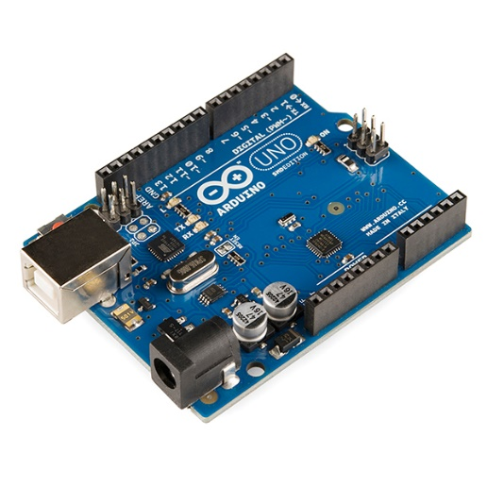

Fig.3.3: Arduino UNO

It can be powered either via USB connection or an external power supply. The Uno is programmed using the Arduino Software (IDE), which is user-friendly and supports a simplified version of C++ programming language. With its versatility and wide range of compatible sensors and shields, the Arduino Uno is widely used in various applications such as robotics, home automation, IoT (Internet of Things), and educational projects.

**3.2** **Dataset description**

3.2.1 Dataset Description for Real Time

The dataset comprises real-time biopotential signals recorded from 10 subjects, including 5 individuals diagnosed with learning disabilities and 5 subjects with hyperactivity. Biopotential signals were captured using BioAmp EXG Pills, with three electrodes strategically positioned on the frontal-central area of each subject's scalp. The signals were then displayed using a Digital Storage Oscilloscope (DSO) and converted to CSV format for analysis. Each record in the dataset represents a specific time segment of biopotential signals, providing information on neural activity associated with error perception and cognitive processing. The dataset aims to facilitate research into the neural mechanisms underlying learning disabilities and hyperactivity, offering insights into error monitoring processes and cognitive control in affected populations.

3.2.2 Dataset Description for Healthy Patients ErrP

In First Experiment, participants engaged in a P300-based BCI speller system, including a tetraplegic participant with minimal hand movements. The EEG signals were recorded using a bio amplifier, pre-processed with notch and band-pass filtering. Participants sequentially focused on letters displayed on a screen to compose words, allowing for error detection and correction within the BCI system. The Second Experiment employed a guessing game scenario between human subjects and a robot, aiming to adapt the robots behaviour based on participants brain responses, particularly error- related potentials (ErrPs). EEG signals were recorded to calibrate subject-specific ErrP decoders, exploring the potential of human-agent co-adaptation in structured interaction scenarios. The Third Experiment focused on choice-reaction time tasks (CRT) with congruent and incongruent feedback conditions. Participants responded to stimuli on a computer screen while EEG signals were recorded using 32 active EEG electrodes. The study aimed to investigate neural correlates of response inhibition and cognitive control processes during task performance. The Fourth Experiment involved EEG recordings and gaze tracking to analyze brain activity and eye movements during visual tasks. Utilizing the 10-10 international system and an eye-tracker device, the study explored spatial filtering techniques to enhance signal quality and investigated the trajectory of on-screen displacements using Hjorth descriptors.

3.2.3 Dataset Description for Schizophrenia patients

The study involved 22 Healthy Controls and 26 Schizophrenia Patients, examining various types of schizophrenia such as undifferentiated and paranoid. Participants were recruited through advertisements and referrals, with strict screening criteria applied to ensure eligibility. Clinical assessments and experimental tasks were conducted to investigate brain function differences between schizophrenia patients and healthy individuals. EEG recordings were used to analyze brain activity patterns. This dataset description provides valuable insights into the study design and participant characteristics, shedding light on schizophrenia's impact on brain function.

**CHAPTER 4**

**SYSTEM ARCHITECTURE**

The project utilized the subsequent system architecture:

* 1. **Circuit Diagram**

EEG circuits, like the one depicted in a schematic diagram, amplify the tiny electrical signals produced by brain activity. These weak signals are picked up by electrodes placed on the scalp and fed into the circuit. The circuit amplifies the signal and filters out noise before sending it to a device like an Arduino for processing and recording. While this offers a basic overview, building a safe and effective EEG system requires specialized medical-grade equipment and expertise due to the sensitivity of the measurements and potential safety risks.

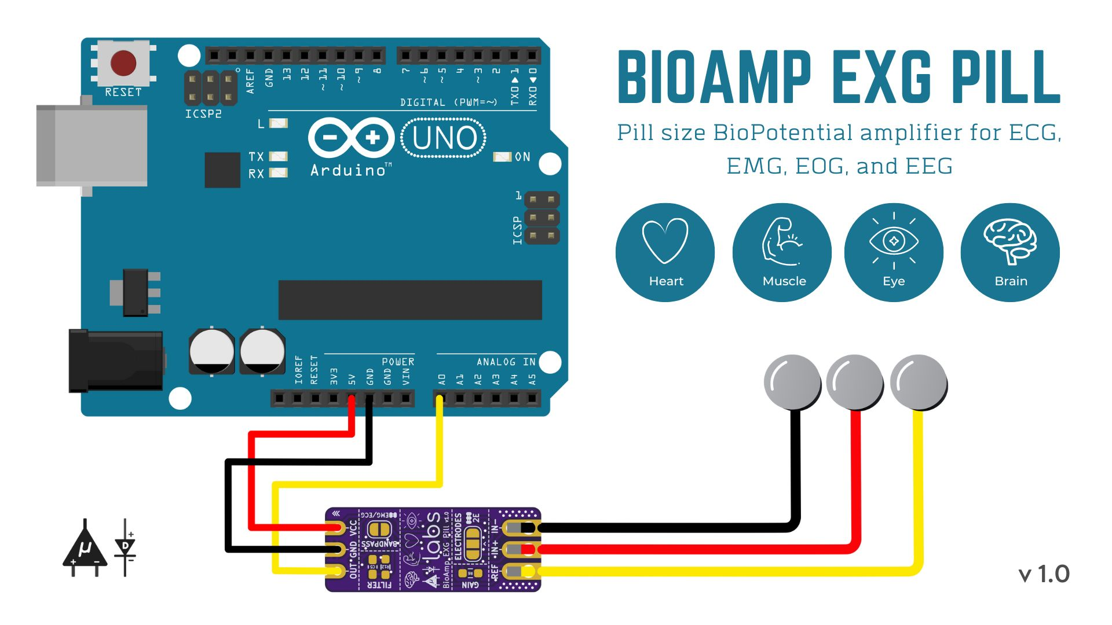

Fig.4.1: Circuit Diagram

* 1. **Block Diagram**

The block diagram of ErrP Detection system is given below:

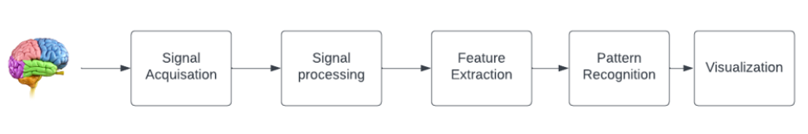

Fig.4.2: Block Diagram

1. Signal Acquisition:

Electroencephalography (EEG) signal acquisition involves placing electrodes on specific areas of the scalp, guided by the international 10-20 system. These electrodes capture electrical activity generated by neurons in the brain's frontal, central, and parietal lobes. EEG signals provide valuable insights into various cognitive processes. Proper electrode placement and signal acquisition techniques are crucial to ensure accurate representation of brain activity.

1. Signal Processing:

Once EEG signals are acquired, signal processing techniques are applied to refine the data. This includes eliminating noise and inconsistencies that may obscure the underlying brain activity. Filtering methods such as high-pass, low-pass, band-pass, and notch filters are used to remove unwanted frequency components. Down sampling techniques may be employed to reduce the sampling rate while preserving essential information. Additionally, outlier detection and removal methods help to identify and discard anomalous data points, ensuring the integrity of the analysis.

1. Feature Extraction:

Feature extraction is a critical step in EEG signal processing, where distinct characteristics of the signals are identified. These features may include spectral features like power spectral density, temporal features such as amplitude and frequency of oscillations, or spatial features like coherence between electrode locations. Feature extraction reduces the dimensionality of the data while retaining relevant information necessary for subsequent analysis.

1. Pattern Recognition:

In pattern recognition, the extracted features are utilized to identify patterns or signatures in the EEG signals. For instance, researchers may seek to identify specific patterns of brain activity associated with stimuli presentation or cognitive events. Machine learning algorithms such as support vector machines, neural networks, or Bayesian classifiers are commonly employed for pattern recognition tasks, aiding in the understanding of cognitive processes and neurological disorders.

1. Visualization:

The final step involves visually presenting the processed EEG signals for analysis and interpretation. Visualization techniques such as time-domain plots, frequency-domain plots (e.g., spectrograms), topographic maps, and error-related potential (ErrP) plots facilitate the exploration of temporal dynamics, spatial distributions, and frequency characteristics of the EEG signals. Graphical representation enhances understanding and aids in identifying meaningful insights, contributing to advancements in neuroscience research and clinical applications.

* 1. **Methodologies**

4.3.1 Methodology of the error-detection five eye-gazing experiments

Our study encompassed a series of five eye-gazing experiments designed to investigate the nuances of Error-Related Potentials (ErrPs) observed in EEG signals across diverse experimental conditions and participant demographics.

crucial juncture Single Channel EEG Brain Activity during the Task

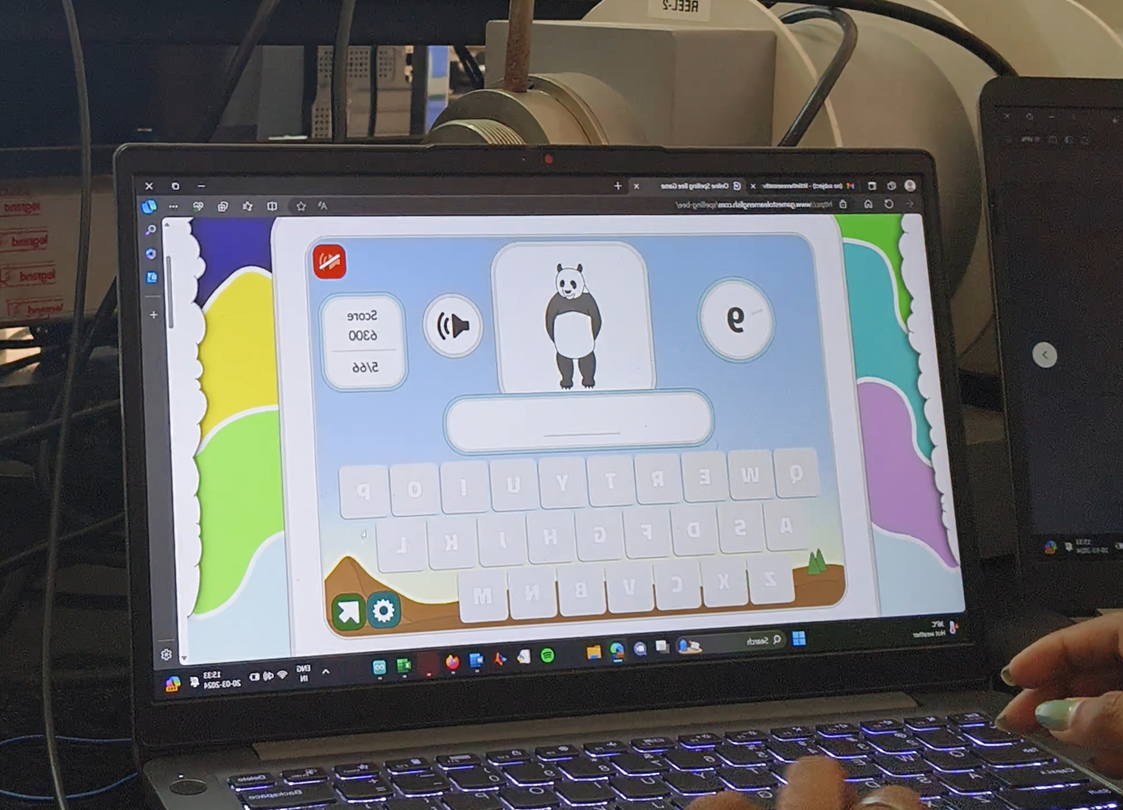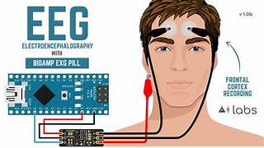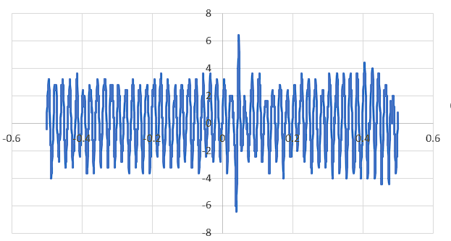

Fig.4.3: Healthy controls (Understanding Error Monitoring Mechanisms through EEG Analysis)

crucial juncture  Single Channel EEG  Brain Activity during the Task

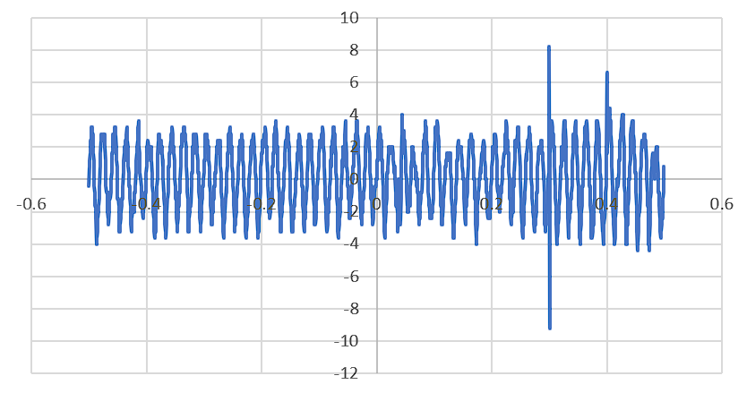

Fig.4.4: Learning Disability Patients(Understanding Error Monitoring Mechanisms through EEG Analysis)

The main aim was to identify potential differences in ErrP patterns triggered by various stimuli and among individuals, as depicted in Fig. 4.3 and Fig. 4.4, to understand Error Monitoring Mechanism through EEG Analysis. The findings revealed that individuals with learning disabilities exhibited ErrP with a higher negative peak compared to healthy individuals, indicating distinct neural responses in error processing.

**Participant Recruitment and Characteristics:**

Participants were recruited from the local community through advertisements and word-of-mouth referrals. A diverse sample was sought to ensure variability in demographic characteristics such as age, gender, and educational background. Informed consent was obtained from all participants prior to their involvement in the study. The inclusion criteria encompassed individuals of early 20’s without a history of neurological or psychiatric disorders that could affect EEG signals.

**Experimental Design:**

Each eye-gazing experiment was meticulously designed to manipulate specific gaze behaviours and cognitive processes while recording EEG signal. Stimuli presentation and task instructions varied across experiments to elicit distinct cognitive responses, including error detection and attentional processes. Experimental conditions were randomized to minimize order effects, and counterbalancing techniques were employed to control for potential confounding variables. Each participant completed all five experiments, with short breaks provided between sessions to minimize fatigue and maintain engagement.

**EEG Signal Acquisition Setup:**

EEG signals were recorded using a BioAMP EXG Pill acquisition integrated circuit (IC) specifically designed for EEG signal acquisition, connected to an micro-controller programmed with custom scripts for data acquisition and processing. Two electrodes were positioned at the frontal-central region of the participant's scalp, while the third electrode served as the reference electrode. Electrode impedance was maintained below 5 kΩ to ensure optimal signal quality. The hardware setup was complemented by a Digital Storage Oscilloscope (DSO) for real-time visualization of the recorded EEG signals, allowing for immediate feedback during data collection.

**Experimental Procedure:**

Participants were comfortably seated in a dimly lit room, with the experimental setup explained to them before commencement. They were instructed to maintain a relaxed but attentive state throughout the experiment and to minimize head and body movements to prevent artifact contamination in the EEG signals. Each experiment consisted of multiple trials, with participants instructed to fixate their gaze on a central stimulus while responding to task-specific cues or prompts presented on a computer monitor. EEG signals were continuously recorded during the experiment, with trials lasting between 3 to 5 minutes each to capture a sufficient number of epochs for subsequent analysis.

**Data Analysis:**

Recorded EEG signals were per-processed to remove noise and artifacts using standard techniques, including filtering, artifact rejection, and baseline correction. Epochs corresponding to specific experimental conditions were extracted from the pre--processed EEG data for further analysis. Time-domain and frequency-domain features were computed from the EEG epochs to characterize the neural responses associated with error processing and attentional modulation. Statistical analyses, were performed to examine the effects of experimental manipulations and individual differences on ErrP amplitude and latency.

**Graphical Output and Interpretation:**

The graphical outputs obtained from each experiment depicted the temporal dynamics of ErrPs across different experimental conditions and participant groups. Visual inspection of the ErrP waveforms revealed distinct patterns of neural activity associated with error detection and cognitive processing. Quantitative analysis of the graphical data allowed for the identification of significant differences in ErrP characteristics between experimental conditions and among participants. These findings provided valuable insights into the neural mechanisms underlying error monitoring and attentional processing, highlighting the complex interplay between cognitive processes and neural activity.

Methodology involved a comprehensive approach to investigate Error-Related Potentials (ErrPs) in EEG signals through a series of eye-gazing experiments. By manipulating experimental conditions and participant demographics, we aimed to elucidate the intricacies of neural responses associated with error processing and attentional modulation. The utilization of advanced EEG signal acquisition techniques, coupled with meticulous experimental design and data analysis, enabled us to uncover subtle variations in ErrP patterns and their implications for cognitive neuroscience research. Through this methodology, we contribute to the growing body of literature on error monitoring and cognitive control, paving the way for future studies to further elucidate the underlying mechanisms of cognitive processing.

**CHAPTER 5**

**RESULT AND DISCUSSION**

In the study, an investigation into Error-related Potentials (ErrP) was conducted using data from various sources. Firstly, healthy individuals were tasked with plotting ErrP graphs alongside corrected graphs, providing valuable insights into the typical response patterns of this neural phenomenon. Additionally, ErrP signals were obtained from a dataset comprising individuals diagnosed with schizophrenia, allowing for comparative analysis between healthy and clinically affected populations. Moreover, the research extended to include real-time ErrP signals from a cohort of 10 subjects with learning disabilities, aiming to broaden understanding of ErrP across diverse cognitive profiles. The results derived from these datasets are poised to offer significant contributions to the field, potentially shedding light on the underlying neural mechanisms of error processing in both healthy and clinical populations, thereby paving the way for more targeted interventions and treatments for conditions affecting cognitive processing and error monitoring.

**5.1 Analyzing ErrP Patterns in Healthy Patients**

The four tasks described involve investigating error-related potentials (ErrPs) in various contexts: typing tasks, human-robot interaction (HRI), and brain-computer interface (BCI) speller tasks. By analyzing EEG signals, these tasks aim to understand neural responses associated with error perception, facilitating adaptive behaviour and real-time feedback. The ErrP graph plots, depicting average brain activity waveforms for correct and error trials, highlight variations in neural responses. These tasks hold significance for improving human-robot interaction and developing more intuitive BCI systems.

ErrP pattern recognition is crucial for decoding neural signals and informing adaptive behavior in real-world applications. Importantly, these tasks can be applied to healthy patients to study cognitive processes, enhance human-computer interaction, and develop assistive technologies for individuals with motor disabilities or communication disorders, ultimately improving quality of life.

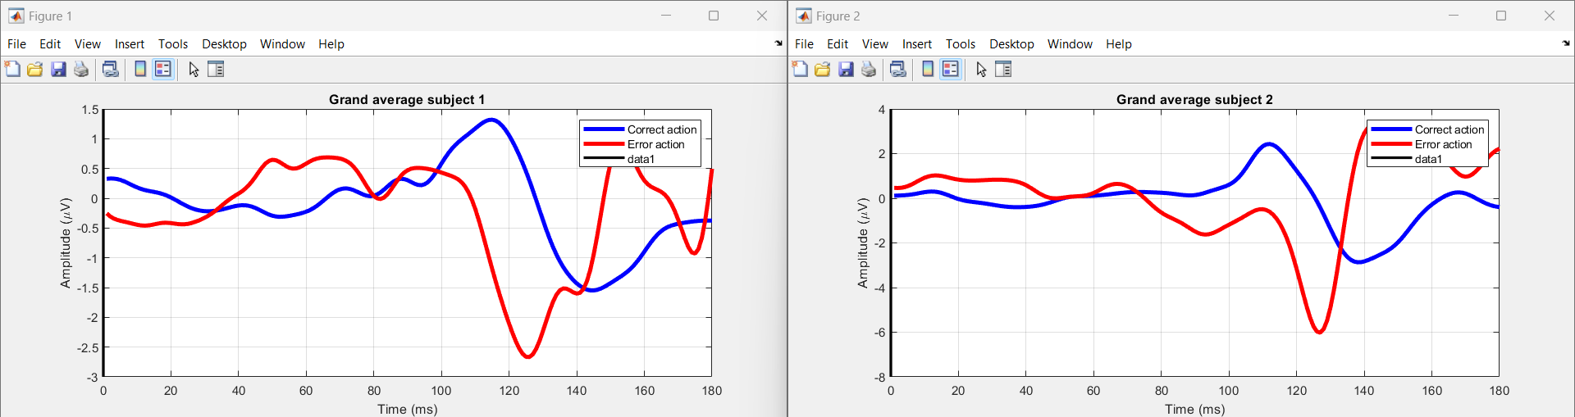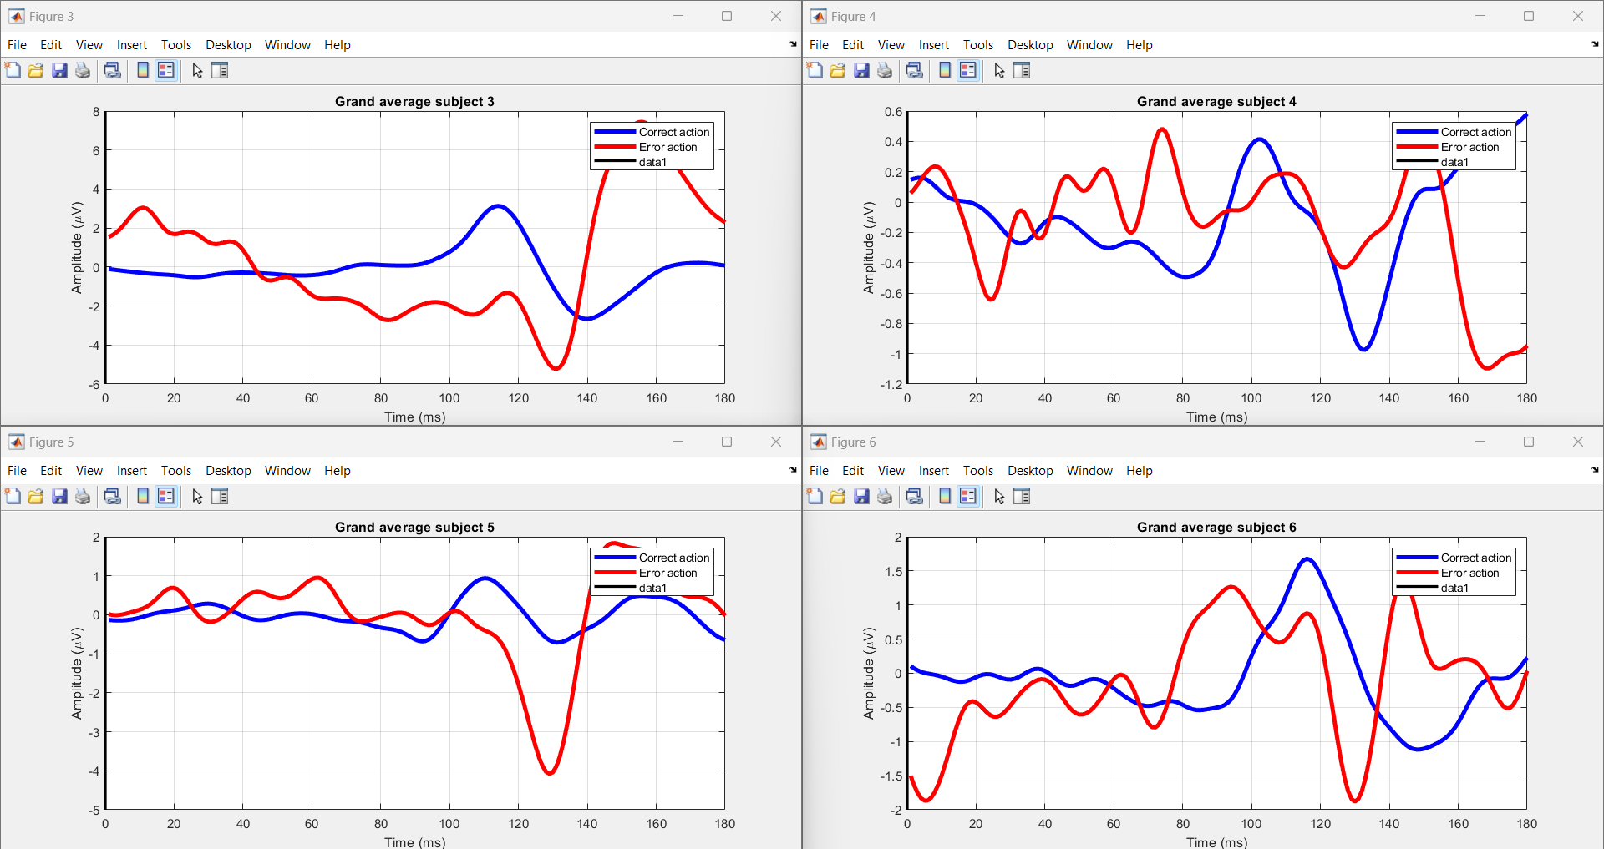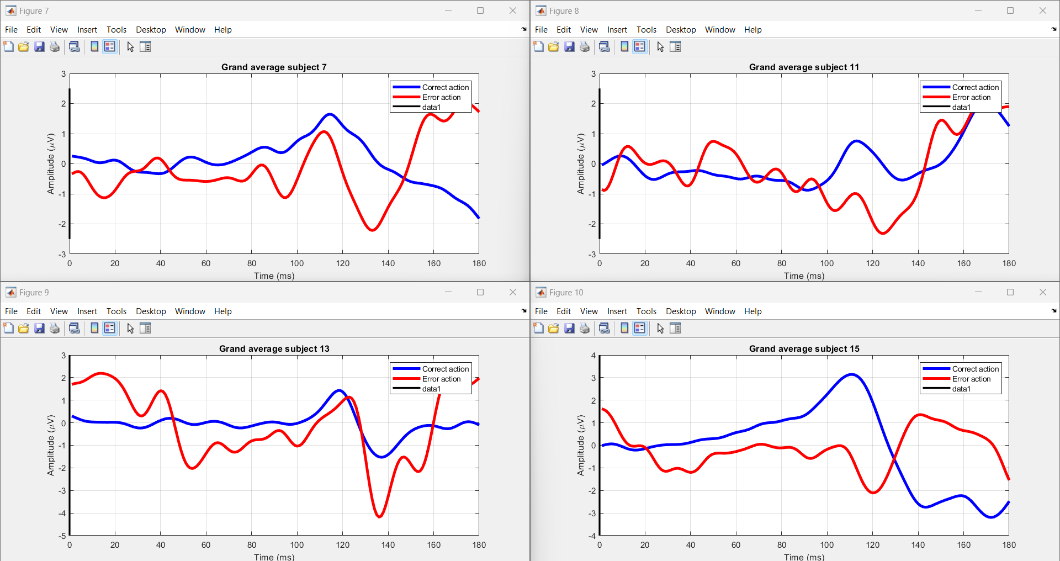

Fig.5.1: Errp pattern Recognition by using Gaze based keyboard task.

The task at hand involves investigating the physiological responses associated with error perception during typing tasks,in Fig.5.1 The graph will superimpose the average brain activity waveforms for both correct and error trials, accentuating variations in neural responses between the two. Each session comprises typing a sentence followed by a brief pause. Data encompassing typing speed, accuracy, and error detection are collected. The EBNeuro EEG device records brain electrical activity using 64 wet electrodes, while the SMI myGaze eye-tracker captures gaze movements on the screen. The Lab Streaming Layer software synchronizes EEG and eye-tracking data streams for coherent analysis. Segmented into epochs, data epochs capture physiological responses around key presses. Support Vector Machine (SVM) models are employed for classifying correct and erroneous typesetting based on collected data. The process involves data loading, preprocessing, feature extraction, dataset splitting, and training SVM models. Code functionalities include loading EEG data, visualizing EEG activity for each subject, and saving processed data into MAT files for further analysis.

The study involves 10 participants, aiming to understand the interplay between physiological responses and error perception during typing tasks. The experiment involved segmenting the concurrent data streams into epochs, each spanning from 200 ms before the onset of a visual key press to 700 ms afterward. This segmentation allowed for the analysis of physiological responses during typing events.Machine learning models, specifically Support Vector Machines (SVMs), were employed to classify correct and erroneous typesetting actions based on the collected data. Data preprocessing involved handling missing values, normalizing features, and transforming the data into a format suitable for SVM training. Relevant features characterizing correct and erroneous typesetting, such as font size, spacing, and alignment, were extracted for input into the SVM model. In this study, the primary objective was to investigate the physiological responses associated with error perception during typing tasks. Participants engaged in typing sentences followed by short breaks while their physiological signals were recorded using EEG (Electroencephalography) and eye-tracking technology. This comprehensive approach allowed for the exploration of physiological correlates of error perception during typing tasks, shedding light on the underlying mechanisms of human error detection and correction.

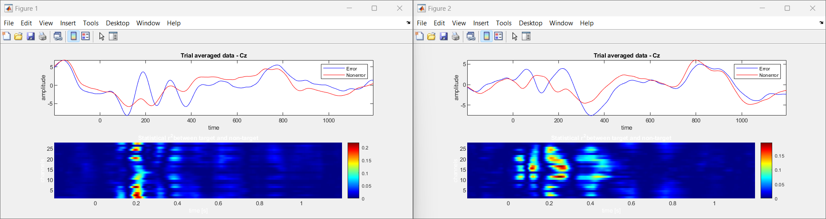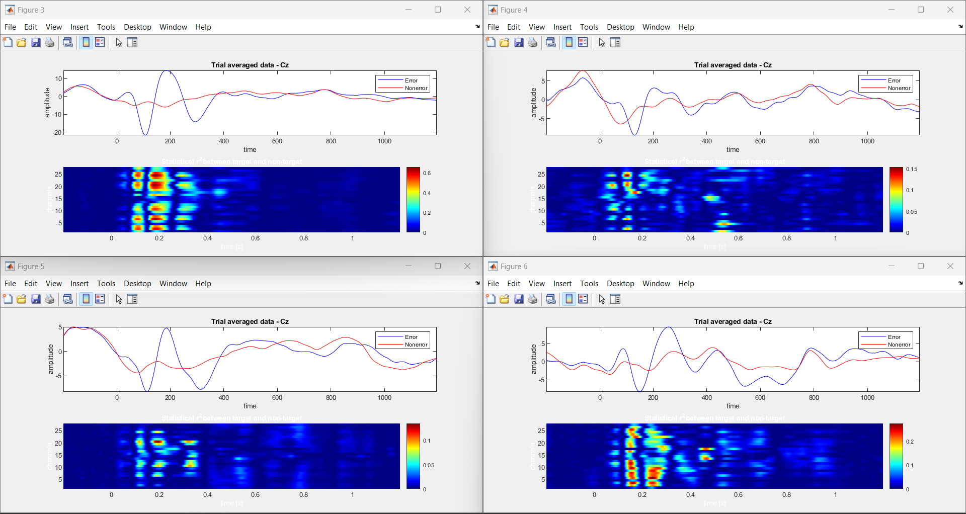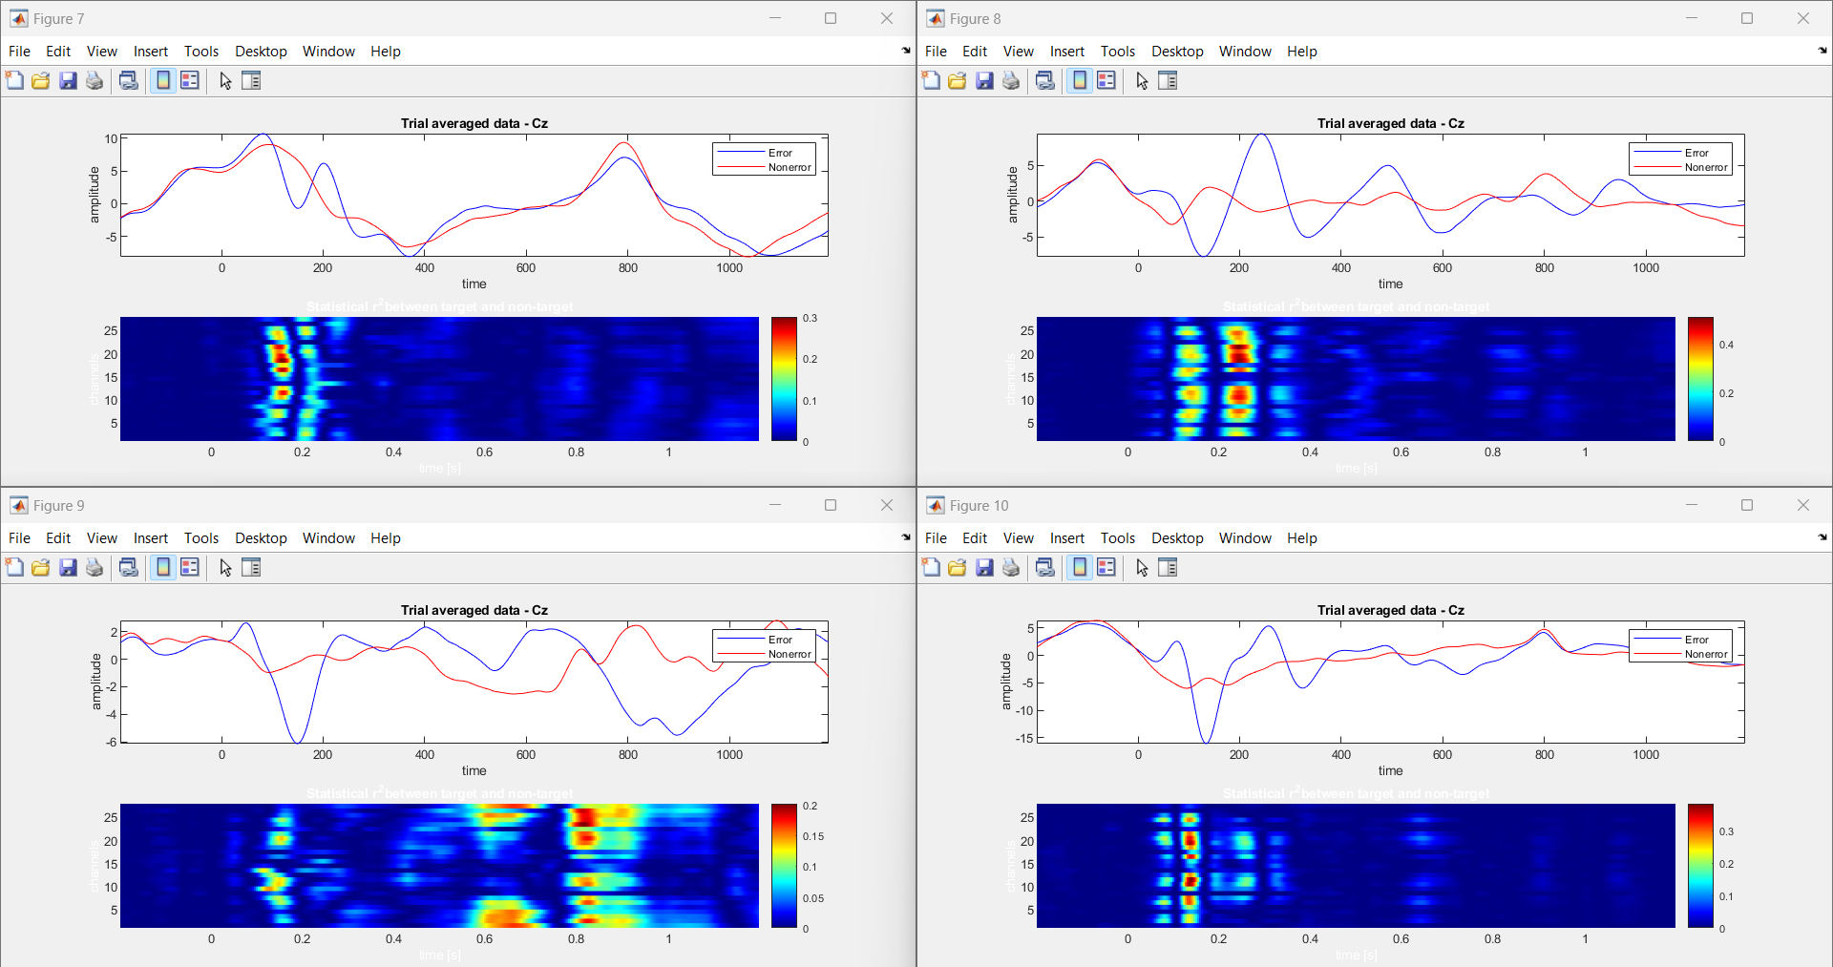

Fig.5.2: Errp pattern Recognition by using Human-Robot Interaction.

The Human-Robot Interaction (HRI) investigates EEG-based ErrPs (error-related potentials) during interactions with a humanoid robot in a simplified task. Using an ActiCHamp amplifier with electrodes, the study captures brain activity time-locked to robot actions. Advanced signal processing and high-quality signal acquisition ensure accurate data collection. MATLAB is employed for preprocessing, including common average reference application and band-pass filtering. This involves applying common average reference methods and band-pass filtering to enhance the quality of the EEG signals. Epoching and event selection techniques are then applied to isolate and focus the analysis on instances where feedback is presented, allowing for a detailed examination of relevant neural responses.

Epoching and event selection focus analysis on relevant feedback presentation instances. Support Vector Machine (SVM) classification is utilized for error detection. The project emphasizes visualizing average ErrP signals, highlighting differences between correct and error trials.Fig.5.2 enables understanding of neural responses to robot-induced errors, facilitating adaptive behavior and real-time feedback. By decoding EEG signals, the study informs the robot's actions, enhancing its interaction capabilities. The study findings hold significance for improving human-robot interaction by enabling robots to adjust behaviors based on neural responses.The field of Human-Robot Interaction (HRI) delves into understanding how humans and robots interact, with a recent focus on utilizing EEG-based ErrPs (error-related potentials) during interactions with humanoid robots. The study prioritizes advanced signal processing techniques and high-quality signal acquisition to ensure precise data collection. A crucial aspect of the project is the visualization of average ErrP signals. By comparing EEG responses between correct and error trials, researchers can discern distinct patterns associated with error perception. This visual representation aids in understanding the neural mechanisms underlying responses to robot-induced errors, laying the groundwork for developing adaptive behaviours and providing real-time feedback in human-robot interactions.

Ultimately, the study's findings have significant implications for improving human-robot interaction. By incorporating neural responses into the interaction process, robots can adapt their behaviours in real-time, leading to more seamless and efficient collaborations between humans and machines.

Fig.5.3: Errp pattern Recognition by using P300 based BCI speller.

The task investigates error-related potentials (ErrPs) and P300 event-related potentials (ERPs) in EEG data, particularly focusing on human-robot interaction (HRI). EEG signals are acquired using an ActiCHamp amplifier,in Fig.5.3 capturing brain activity during interactions with a humanoid robot in a simplified task. Preprocessing involves filtering EEG data to extract relevant neural signals, followed by ErrP data extraction and labeling. The processed data, including participant IDs and session information, are stored for analysis. The project utilizes MATLAB for data processing and visualization, including plotting average EEG signals at channel Fz for correct and error conditions. This analysis aids in understanding neural responses to robot-induced errors, facilitating adaptive behavior and real-time feedback. The task aims to improve human-robot interaction by enabling robots to adjust behaviors based on neural responses, enhancing the efficiency and reliability of the interaction process.

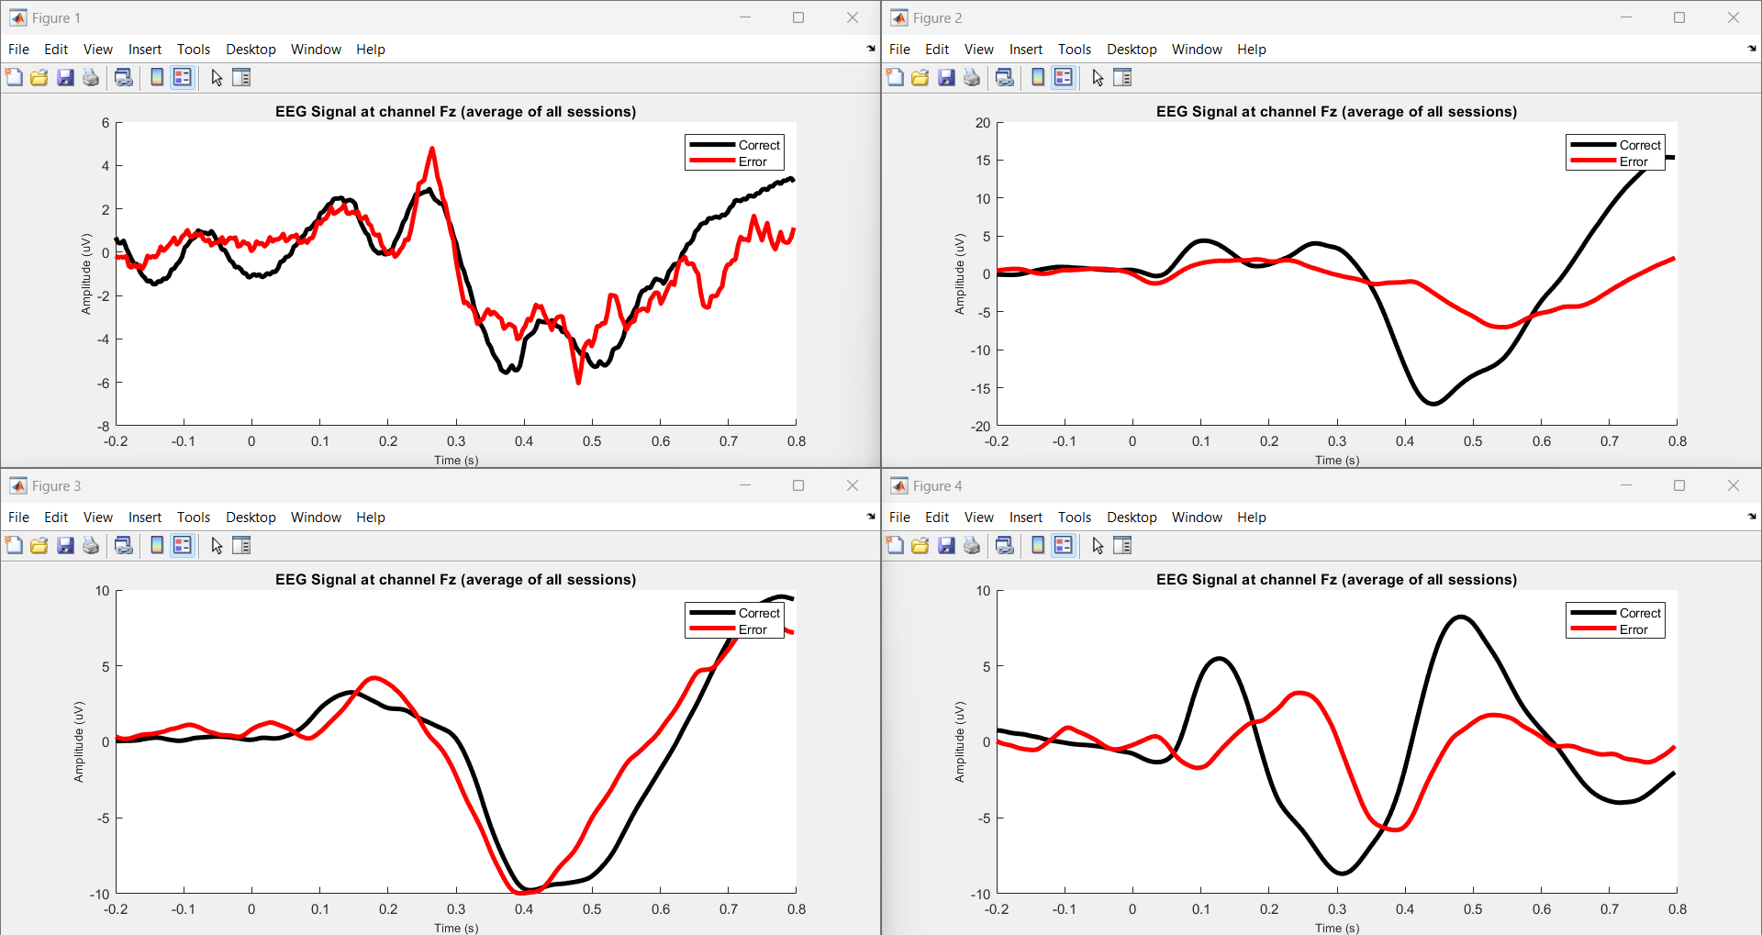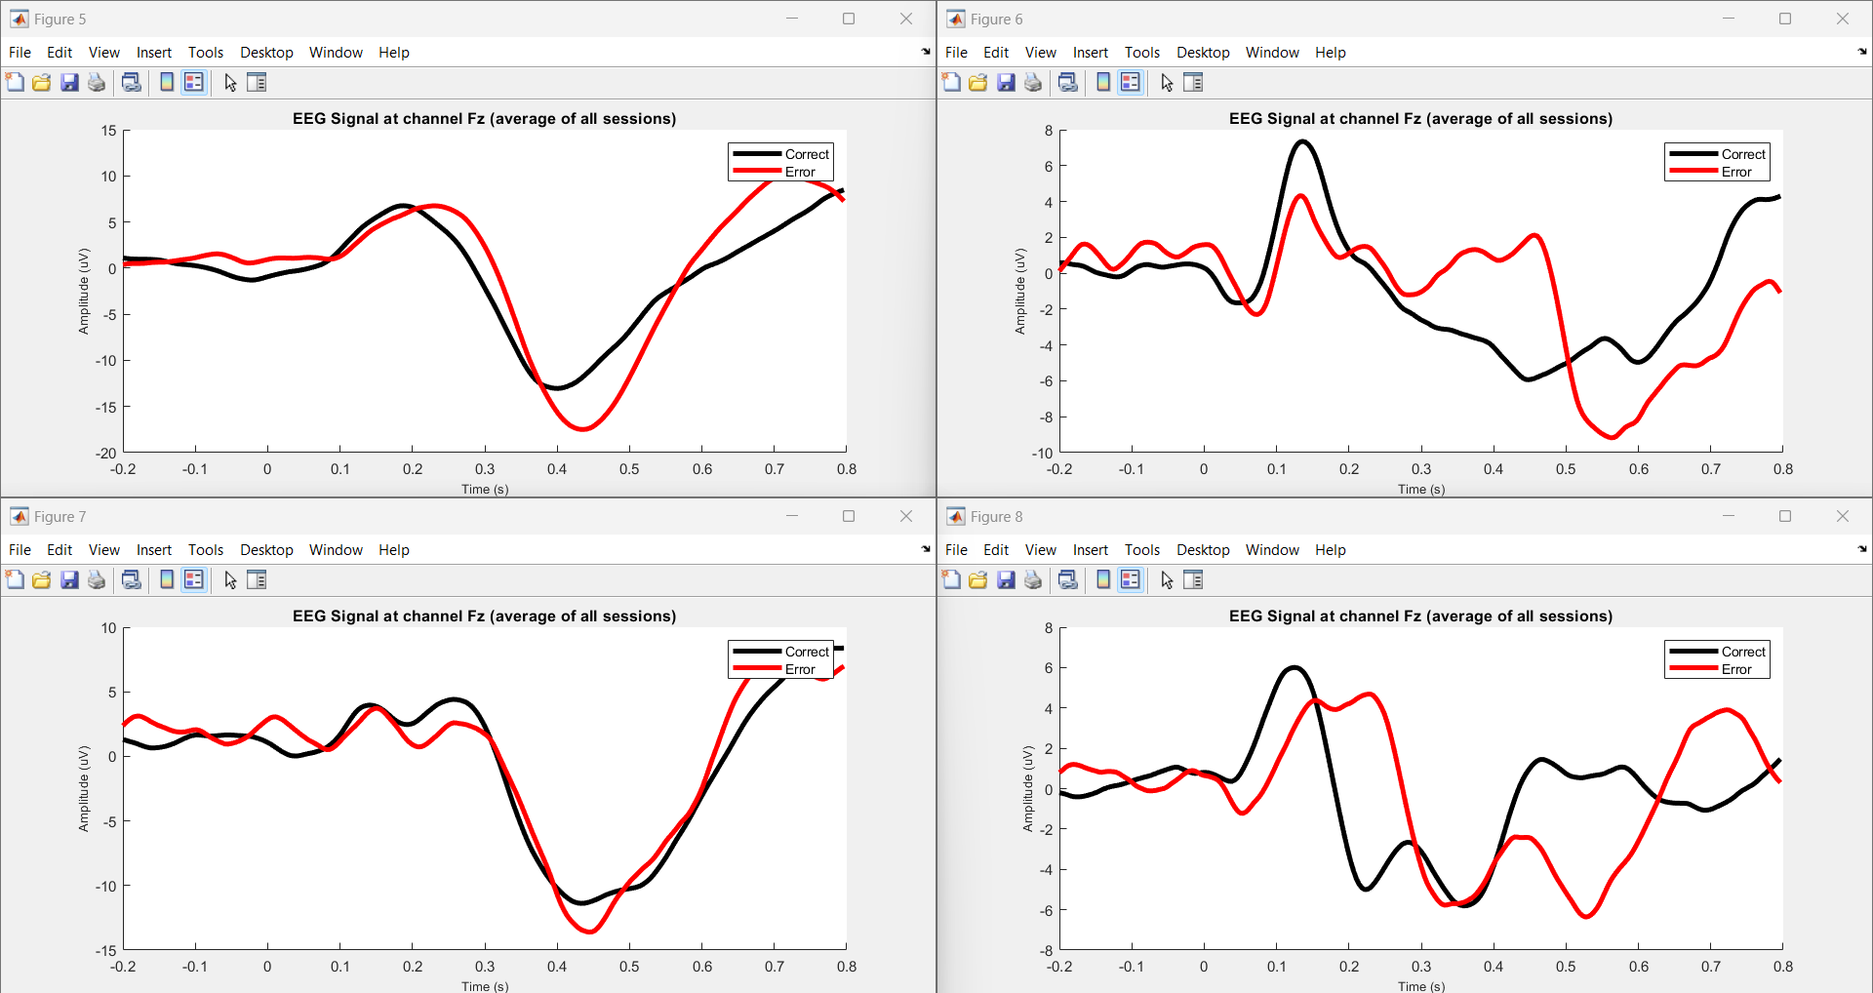

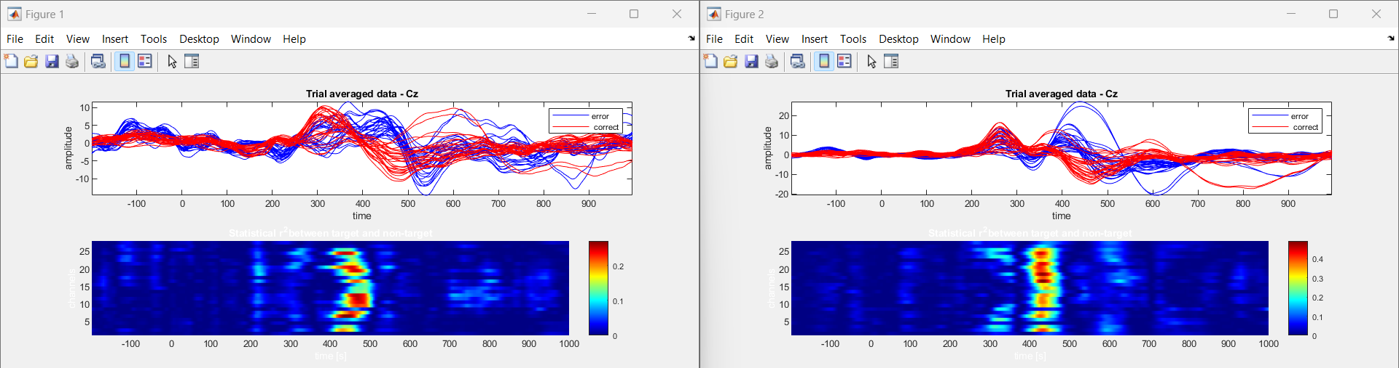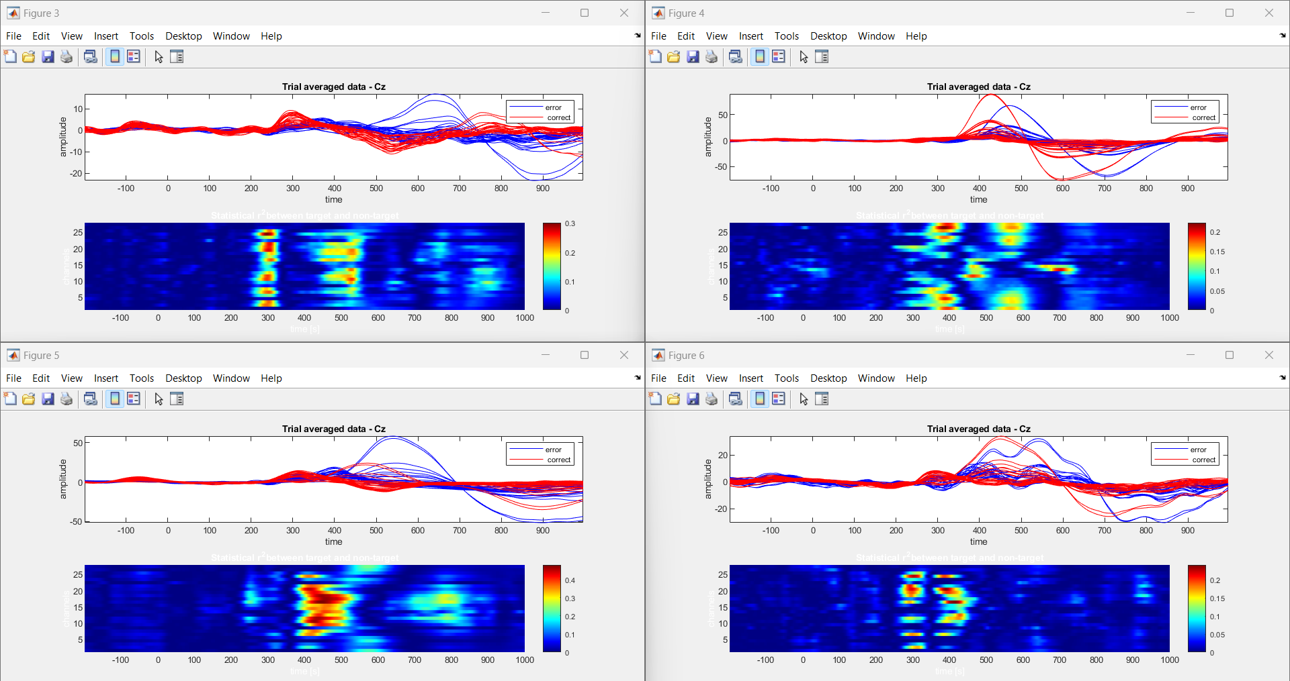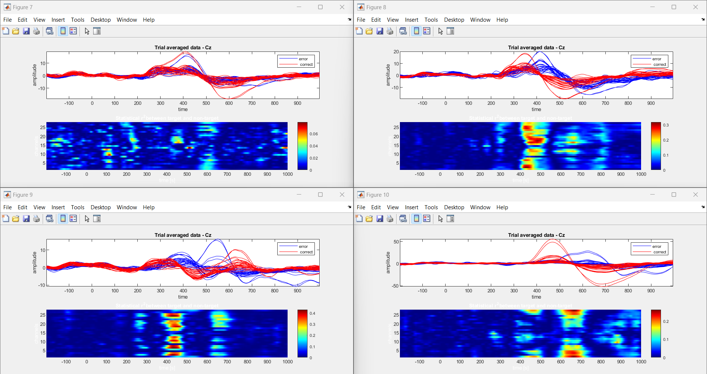

Fig.5.4: Errp pattern Recognition by using Human-Agent Co-Adaptation

In "Human-agent Co-adaptation using Error-related Potentials", participants engaged in a guessing game with a robot partner. EEG data was acquired during two main phases: a calibration session and closed-loop co-adaptation sessions. The calibration session involved participants guessing the robot's chosen object, while closed-loop sessions continued this interaction. EEG signals were analyzed by using Fig.5.4 to decode error-related potentials (ErrPs), indicative of participant's error perception. The robot's behavior adapted based on these decoded ErrPs, fostering human-agent co-adaptation. Data analysis involved preprocessing EEG signals, extracting features, and decoding ErrPs for real-time feedback. Graphical analysis of ErrPs provided insights into participants' error perception dynamics, facilitating adaptive behavior in the robot. Overall, the task aimed to enhance human-agent collaboration through real-time neural signal processing.

|  |  |  |  |  |  |  |
| --- | --- | --- | --- | --- | --- | --- |
| Sub. | Gaze based keyboard task | | | Human-Robot Interaction | | |
| Amplitude | | Time(ms) | Amplitude | | Time(ms) |
| Negative | Positive | Negative | Positive |
| 1 | -2.667 | 0.96 | 126 | -7.997 | 3.655 | 125 |
| 2 | -6.018 | 3.251 | 127 | -7.249 | 1.07 | 355.5 |
| 3 | -5.144 | 7.432 | 132 | -20.9 | 14.11 | 113.3 |
| 4 | -0.43 | 0.4427 | 127 | -9.071 | 2.981 | 136.7 |
| 5 | -4.08 | 1.836 | 128 | -7.847 | 4.801 | 121.1 |
| 6 | -1.881 | 1.375 | 130 | -8.003 | 9.226 | 156.3 |
| 7 | -2.194 | 1.693 | 133 | -7.915 | 7.042 | 378.9 |
| 8 | -2.316 | 1.45 | 125 | -7.755 | 9.369 | 128.9 |
| 9 | -4.185 | 2.133 | 137 | -5.946 | 1.746 | 156.3 |
| 10 | -2.098 | 3.143 | 121 | -15.98 | 5.343 | 136.7 |

Table 5.1: Error-Related Potentials (ErrP) Across Task Paradigms: Amplitude and Time Characteristics.

|  |  |  |  |  |  |  |
| --- | --- | --- | --- | --- | --- | --- |
| Sub. | P300 based BCI speller | | | Human-Agent Co-Adaptation | | |
| Amplitude | | Time(ms) | Amplitude | | Time(ms) |
| Negative | Positive | Negative | Positive |
| 1 | -6.04 | 1.675 | 479 | -11.75 | 0.933 | 539 |
| 2 | -7.013 | 1.651 | 542 | -6.511 | 27.07 | 335 |
| 3 | -9.973 | 7.651 | 393 | -1.681 | 16.51 | 414 |
| 4 | -5.745 | 1.766 | 393 | -1.326 | 67.42 | 351 |
| 5 | -17.45 | 10.08 | 440 | -1.001 | 55.22 | 335 |
| 6 | -9.164 | 1.44 | 565 | -4.056 | 24.47 | 308.6 |
| 7 | -13.58 | 7.02 | 448 | -33.029 | 16.81 | 218.8 |
| 8 | -6.342 | 3.795 | 530 | -1.085 | 19.79 | 293 |
| 9 | - | - | - | -1.866 | 15.49 | 433 |
| 10 | - | - | - | -2.503 | 25.65 | 518 |

The Table 5.1 presents EEG patterns associated with error-related potentials (ErrP) across various tasks, highlighting their negative and positive amplitudes along with corresponding time points. Negative amplitudes typically signify neural responses indicating error detection, occurring shortly after the error event. Positive amplitudes often follow, indicating subsequent error processing or correction. By documenting these patterns across tasks, the table facilitates the identification and interpretation of ErrP components, aiding researchers in understanding cognitive processes related to error perception and response. This comprehensive analysis provides valuable insights into neural dynamics during task performance and error monitoring across diverse contexts.

**5.2 EEG ErrP Dataset Comparison between Schizophrenia and Healthy Controls**

In our study, we conducted analyses comparing EEG signals during a button-tone task between individuals diagnosed with schizophrenia and healthy controls. The preprocessing of EEG data ensured data quality by removing artifacts. Subsequently, we plotted the EEG signals recorded during the task for both groups using Python. Our analysis aimed to gain insights into the neural mechanisms underlying schizophrenia and potential differences in task performance between the two groups. Notably, individuals with schizophrenia may experience predictive coding failures, leading to inappropriate salience of sensations that should have been predicted but were not. These failures in predictive mechanisms can influence the suppression of neural responses, including the reduced suppression of the negative peak observed in individuals with schizophrenia.

Moreover, cognitive impairments such as deficits in attention, working memory, and executive functions may further impact the suppression of neural responses in individuals with schizophrenia. Dysfunctional cognitive processes may disrupt the regulation of neural activity, contributing to variations in suppression levels, including the reduced suppression of the negative peak in ERPs observed in schizophrenia compared to healthy controls. The interplay between cognitive impairments, neural processing abnormalities, and predictive coding failures collectively influences the suppression of neural responses, such as the negative peak observed in EEG ERPs. Differences in cognitive functioning and neural mechanisms between healthy controls and individuals with schizophrenia may underlie the observed differences in suppression levels, reflecting the complex interplay of cognitive and neural factors in the disorder.

Overall, our analysis of EEG ErrP datasets highlights the intricate relationship between cognitive impairments, neural processing abnormalities, and predictive coding failures in schizophrenia. These findings contribute to a deeper understanding of the disorder's neurobiology and may inform future research directions and treatment approaches aimed at addressing cognitive and neural dysfunctions in schizophrenia.

Fig.5.5: Dataset comparison between the HC and SZ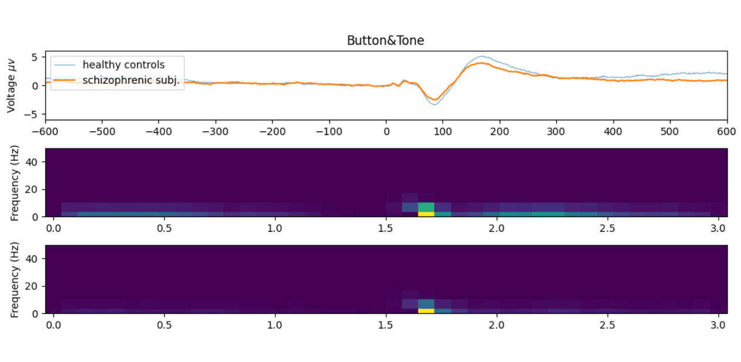.

Table 5.2: Comparison of ErrP features between HC and SZ

|  |  |  |
| --- | --- | --- |
| Feature | Healthy Subjects(HC) | Schizophrenia(SZ) |
| ERP activation strength | Strong | Fainter |
| Time-domain response | Clearer peaks and valleys | Smoother waveforms, potentially reduced differentiation |
| Spatial distribution | Similar topography across electrodes | Potential differences in electrode activation patterns |
| Short-time fourier transform (STFT) | Distinct frequency bands involved | Overlap with human cognition (HC) in the condition, potentially indicating weaker activation. |
| Population-level differences | More consistent responses within group | Higher variability between individuals |

Furthermore, our analysis revealed that individuals with schizophrenia exhibited greater negative suppression compared to healthy controls, as depicted in the graph. This indicates abnormal neural response patterns in schizophrenia, particularly in error monitoring tasks. The heightened negative suppression observed suggests underlying neurobiological dysregulation contributing to cognitive deficits and altered error processing mechanisms in the disorder. These findings underscore the significance of understanding these mechanisms for improving diagnostic and therapeutic strategies for schizophrenia.

**5.3 Error-related Potentials (ErrP) Acquisition in Subjects with Learning Disabilities**

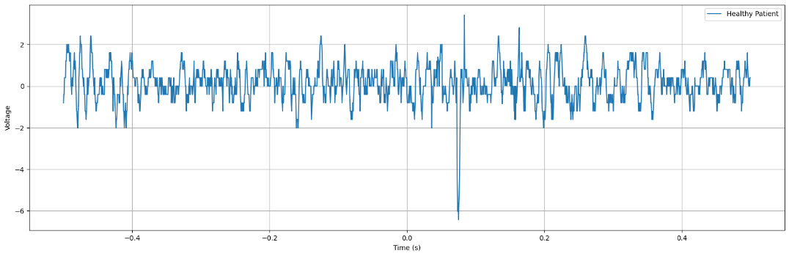In this study, EEG techniques captured real-time neural activity associated with Error-related Potentials (ErrP). Three electrodes placed strategically on participants' frontal-central scalps recorded neural signals linked to error monitoring. Graphical representations and CSV files enabled detailed analysis, offering insights into cognitive processing in real-time. Differences in ErrP patterns between conditions and participant groups were observed, highlighting the interplay between cognitive processes and neural activity. This approach contributes to understanding error monitoring mechanisms and cognitive control, with implications for targeted interventions in various populations.

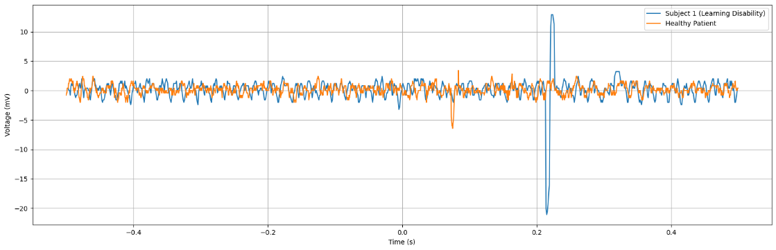Fig.5.6: Healthy control

Fig.5.7: Comparison between Healthy patient and Subject 1(Learning Disability)

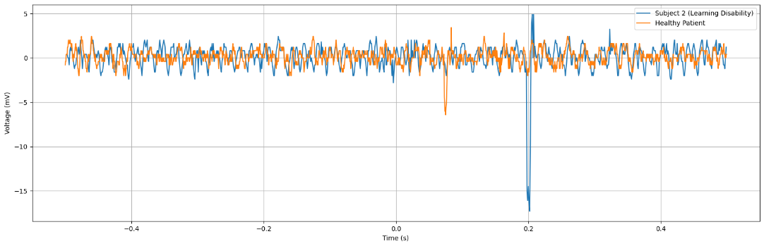

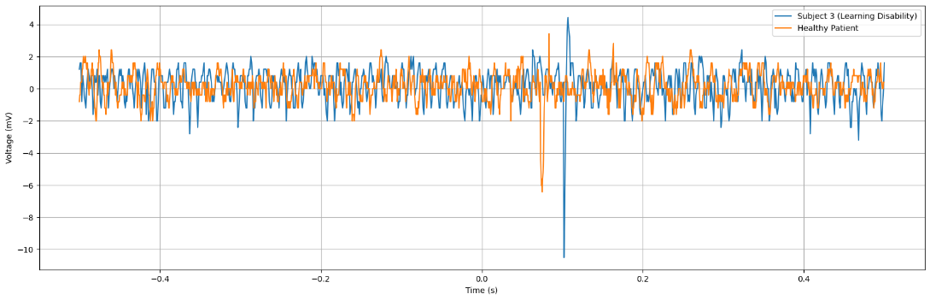Fig.5.8: Comparison between Healthy patient and Subject 2 (Learning Disability)

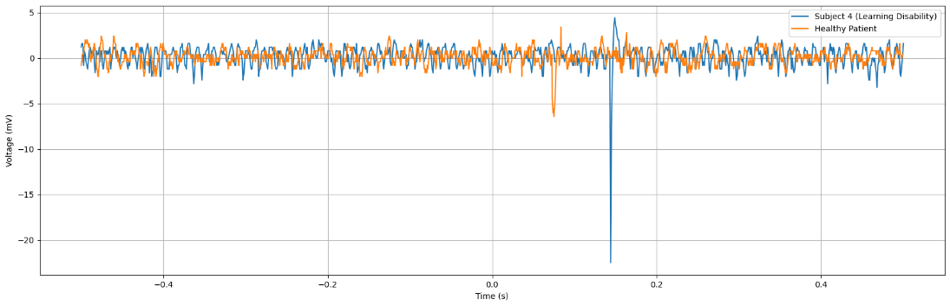Fig.5.9: Comparison between Healthy patient and Subject 3 (Learning Disability)

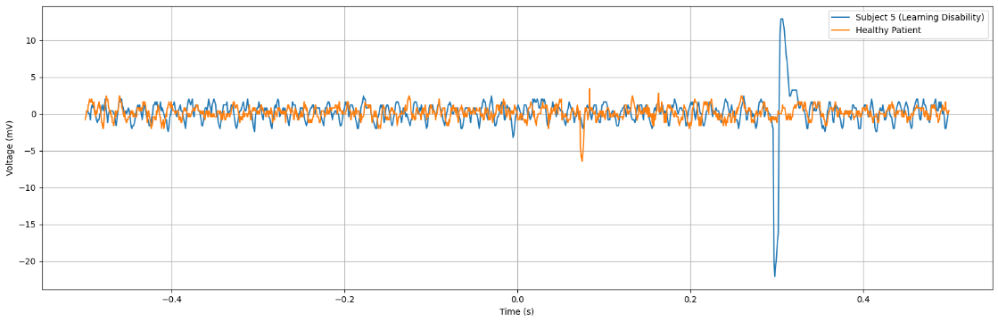Fig.5.10: Comparison between Healthy patient and Subject 4 (Learning Disability)

Fig.5.11: Comparison between Healthy patient and Subject 5 (Learning Disability)

The figures shown above is the real-time Error-related Potentials (ErrP) for individuals with learning disorders compared to healthy subjects reveals notable differences. Firstly, the negative peak observed in the ErrP waveform is significantly higher in individuals with learning disorders compared to healthy subjects. This heightened negative peak indicates amplified neural responses associated with error detection processes in individuals with learning disorders. Additionally, there is a noticeable delay of 20 milliseconds between the ErrP waveform of healthy subjects and those with learning disorders. This temporal difference suggests altered neural processing dynamics in error perception among individuals with learning disorders, potentially reflecting underlying cognitive differences. These findings underscore the significance of understanding and addressing neural processing variations in learning disorders to improve cognitive functioning and error monitoring in affected individuals.

The research investigated how our brains handle errors using a technique called electroencephalography (EEG). Participants engaged in eye-gazing experiments with varying conditions. Researchers monitored their brain activity through EEG, specifically focusing on error-related potentials (ErrPs). These ErrPs are tiny voltage fluctuations that occur when the brain detects an error. By analyzing the timing and characteristics of these ErrPs across different conditions and participants, the researchers aimed to understand how attention, error processing, and brain activity interact. The findings provide valuable insights into the complex interplay between our thoughts and brain functions, furthering our understanding of cognitive neuroscience.

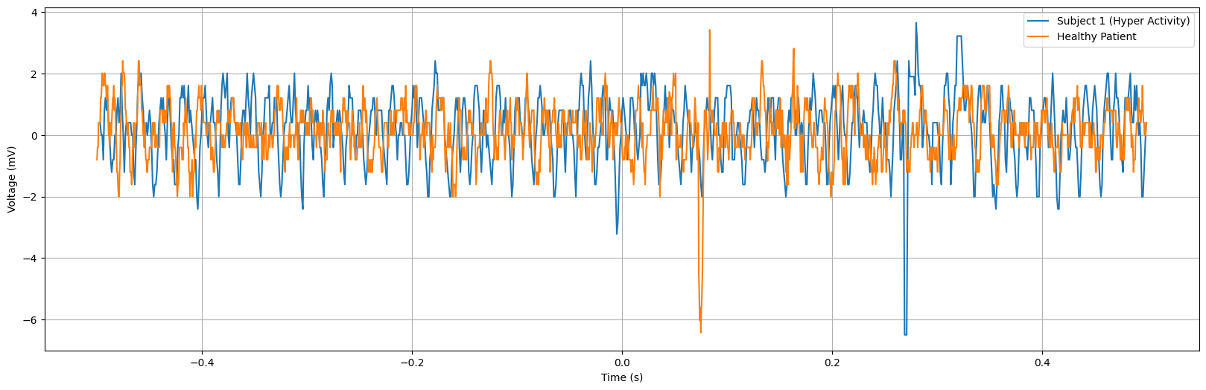The graph depicts Error-related Potentials (ErrP) of subjects with learning disabilities, showcasing a notably higher negative peak occurring around 170 ms after error onset. This heightened negative peak suggests an amplified neural response associated with error detection processes in individuals with learning disabilities. The increased magnitude of the negative peak may reflect intensified neural activity involved in error monitoring and processing among this population.

Fig.5.12: Comparison between Healthy patient and Subject 6 (Hyper Activity)

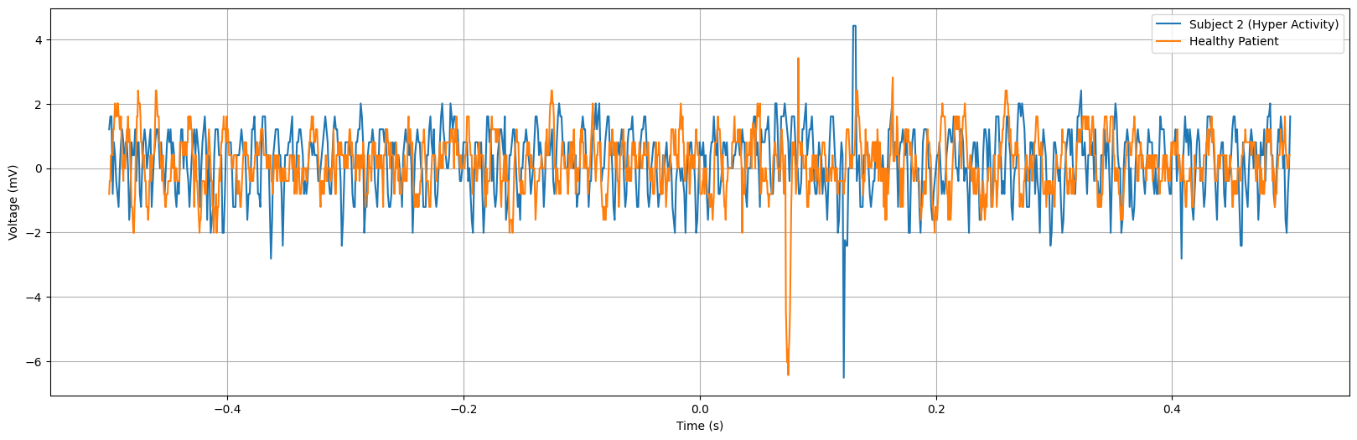

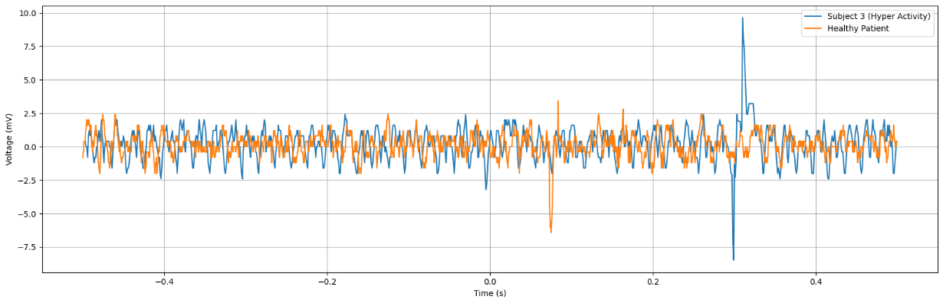Fig.5.13: Comparison between Healthy patient and Subject 7 (Hyper Activity)

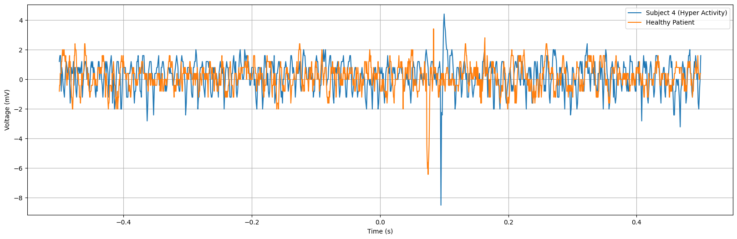 Fig.5.14: Comparison between Healthy patient and Subject 8 (Hyper Activity)

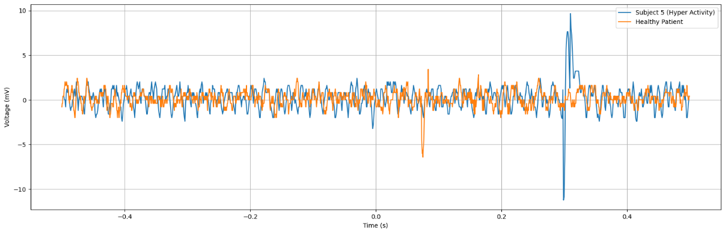 Fig.5.15: Comparison between Healthy patient and Subject 9 (Hyper Activity)

Fig.5.16: Comparison between Healthy patient and Subject 10 (Hyper Activity)

The figures shown above is the observed difference in the amplitude of the negative peak between hyperactive subjects and individuals with learning disorders suggests distinct neural response patterns associated with error monitoring processes in these populations. Hyperactive subjects exhibiting lower amplitudes in the negative peak may indicate altered neural processing or reduced sensitivity to error detection stimuli. This phenomenon could be attributed to differences in cognitive functioning and attentional processes between hyperactivity and learning disorders. While both conditions may impact error monitoring mechanisms, the specific neural mechanisms underlying hyperactivity may result in attenuated neural responses during error perception tasks. Further research is needed to elucidate the precise neural mechanisms contributing to these differences and their implications for cognitive processing in hyperactivity and learning disorders.

Table 5.3: ErrP Graph comparison between Healthy and Unhealthy Patients

|  |  |  |  |  |  |  |
| --- | --- | --- | --- | --- | --- | --- |
| Subjects | Age | Health Condition | Task Performed | Amplitude | | Time(ms) |
|  |  |  |  | Negative | Positive |  |
| 1 | 21 | Healthy | HCI | -6.43 | 3.42 | 75 |
| 2 | 16 | Learning Disorder | HCI | -20.5 | 12.9 | 215 |
| 3 | 20 | Learning Disorder | Gaze speller | -17.3 | 4.90 | 202 |
| 4 | 15 | Learning Disorder | HCI | -24.92 | 22.5 | 296 |
| 5 | 18 | Learning Disorder | HCI | -22.51 | 4.42 | 102 |
| 6 | 22 | Learning Disorder | Gaze speller | -22.1 | 12.1 | 298 |
| 7 | 16 | Hyper Activity | HCI | -9.62 | 2.41 | 314 |
| 8 | 14 | Hyper Activity | Gaze speller | -8.52 | 4.02 | 229 |
| 9 | 13 | Hyper Activity | HCI | -8.50 | 9.65 | 299 |
| 10 | 12 | Hyper Activity | HCI | -8.51 | 4.42 | 55 |
| 11 | 16 | Hyper Activity | Gaze speller | -8.88 | 22.5 | 298 |

The dataset comprises records from 10 subjects, divided into Learning Disorder and Hyperactivity groups, who performed tasks related to Human-Computer Interface (HCI) and Gaze Speller. Each record includes information on the amplitude and time of negative and positive peaks observed in error-related potentials (ErrP) during the tasks. Analysis reveals varying peak amplitudes across tasks within the Learning Disorder group and generally lower negative peak amplitudes in the Hyperactivity group compared to the Learning Disorder group, suggesting potential differences in error monitoring mechanisms between the two conditions.

**5.4 Discussion**

The investigation into Error-related Potentials (ErrP) across various contexts and populations has provided valuable insights into the neural mechanisms underlying error processing and cognitive control. These findings have important implications for understanding cognitive impairments in conditions such as schizophrenia and learning disabilities, as well as for developing targeted interventions and treatments.

1. **Schizophrenia and Abnormal Neural Responses:** The comparison between individuals with schizophrenia and healthy controls revealed distinct neural response patterns during error monitoring tasks. Specifically, individuals with schizophrenia exhibited heightened negative suppression, indicating underlying neurobiological dysregulation. This abnormal neural response pattern may contribute to cognitive deficits observed in schizophrenia, such as deficits in attention, working memory, and executive functions. Understanding these neural mechanisms is crucial for developing targeted interventions to improve cognitive processing and error monitoring in individuals with schizophrenia.
2. **Learning Disabilities and Amplified Neural Responses:** The investigation into ErrP acquisition in subjects with learning disabilities uncovered amplified neural responses associated with error detection processes. This heightened negative peak suggests intensified neural activity involved in error monitoring and processing among individuals with learning disabilities. These findings highlight the importance of understanding cognitive processing mechanisms in diverse populations and developing tailored interventions to improve cognitive processing and error monitoring in individuals with learning disabilities.
3. **Implications for Intervention and Treatment:** The insights gained from ErrP research have significant implications for developing targeted interventions and treatments for conditions affecting cognitive processing and error monitoring. By understanding the neural mechanisms underlying error processing, researchers and clinicians can develop interventions aimed at improving cognitive control and error monitoring abilities in individuals with schizophrenia and learning disabilities. These interventions may include cognitive training programs, neurofeedback techniques, or pharmacological interventions targeting specific neural pathways implicated in error processing.
4. **Future Directions:** Future research in ErrP could focus on further elucidating the neural mechanisms underlying error processing across different populations and contexts. Additionally, longitudinal studies could investigate how neural response patterns change over time and in response to interventions. Furthermore, integrating neuroimaging techniques such as functional magnetic resonance imaging (fMRI) or magnetoencephalography (MEG) with EEG could provide a more comprehensive understanding of the neural circuits involved in error processing.

**CHAPTER 6**

**CONCLUSION**

Based on the investigations into Error-related Potentials (ErrP) across various contexts and populations, significant insights into neural processing associated with error detection and cognitive control have been gleaned. From analyzing EEG patterns in healthy patients to comparing ErrP signals between individuals with schizophrenia and healthy controls, as well as examining ErrP acquisition in subjects with learning disabilities, a comprehensive understanding of the neural mechanisms underlying error processing has been achieved.The findings suggest that individuals with schizophrenia exhibit distinct neural responses during error monitoring tasks, characterized by heightened negative suppression compared to healthy controls. This abnormal neural response pattern highlights underlying neurobiological dysregulation in schizophrenia, potentially contributing to cognitive deficits and altered error processing mechanisms in the disorder. These insights underscore the importance of understanding the complex interplay between cognitive impairments, neural processing abnormalities, and predictive coding failures in schizophrenia for developing targeted interventions and treatments.

Furthermore, the investigation into ErrP acquisition in subjects with learning disabilities revealed amplified neural responses associated with error detection processes. This heightened negative peak suggests intensified neural activity involved in error monitoring and processing among individuals with learning disabilities. Understanding these neural response patterns offers valuable insights into cognitive processing mechanisms in diverse populations, facilitating the development of targeted interventions to improve cognitive processing and error monitoring in individuals with learning disabilities.

**REFERENCES**

1. Cruz A, Pires G and Nunes U J 2018,“Double ErrP detection for automatic error correction in an ERP-based BCI speller”,Ieee Transactions On Neural Systems and Rehabilitation Engineering, Vol. 26, No. 1, January 2018.
2. Stefan K. Ehrlich, Gordon Cheng, “A Feasibility Study for Validating Robot Actions Using EEG-Based Error-Related Potentials” ,Published in International Journal of Social Robotics 11, 271–283 2019.
3. Stefan Ehrlich, “Human-agent co-adaptation using error-related potentials”, 2018J. Neural Eng. in press.
4. Kalaganis F P, Chatzilari E, Nikolopoulos S, Kompatsiaris I and Laskaris N A 2018,“Anerror-aware gaze-based keyboard by means of a hybrid BCI system”,Published in Scientific Reports, Article number: 13176, 4 September 2018.
5. Mine Yasemin,“Single trial detection of error-related potentials in brain–machine interfaces: a survey and comparison of methods”,Published by IOP Publishing Ltd Journal of Neural Engineering, Volume 20, January 2023.
6. Judith M. Ford, Vanessa A. Palzes, Brian J. Roach, and Daniel H. Mathalon, “Did I Do That? Abnormal Predictive Processes in Schizophrenia When Button Pressing to Deliver a Tone”, Advance Access publication July 10, 2013.
7. Yanghao Lei, Bin Shi Dong Wang ,Weizhen Wang, Hao Qu ,Jing Wang,“Improving single-hand open/close motor imagery classification by error-related potentials correction” ,j.heliyon.2023.e18452.
8. Seno B D, Matteucci M and Mainardi L 2010 ,“Online detection of P300 and error potentials in a BCI speller”,Comput. Intell. Neurosci. 2010 307254.
9. Spüler M and Niethammer C 2015, “Error-related potentials during continuous feedback: using EEG to detect errors of different type and severity” ,Front. Hum. Neurosci. 9 155.
10. Bevilacqua M, “On error-related potentials during sensorimotor-based brain-computer interface:explorations with a pseudo-online brain-controlled speller”,IEEE 2022.
11. r. Abiri, s. borhani, E.W. sellers, Y. Jiang, X. Zhao, “A comprehensive review of EEG-based brain-computer interface paradigms”, J. Neural. Eng. 16 (2019) 1–21.
12. Q. Li, Z. Lu, N. Gao, J. Yang, “Optimizing the performance of the visual P300-speller through active mental tasks based on color distinction and modulation of task difficulty”, Front. Hum. Neurosci. 13 (2019) 130.
13. Z. Lu, Q. Li, N. Gao, J. Yang, “Time-varying networks of ERPs in P300-speller paradigms based on spatially and semantically congruent audiovisual bimodality”, J. Neural. Eng. 17 (2020), 046015, 20pp.
14. R. Chavarriaga, J. Millan,” Learning from EEG error-related potentials in noninvasive brain-computer interfaces”, in: IEEE Transactions on Neural Systems & Rehabilitation Engineering A Publication of the IEEE Engineering in Medicine & Biology Society, 18, 2010, p. 381.
15. T. Liu, G. Huang, N. Jiang, L. Yao, Z. Zhang, “Reduce brain computer interface inefficiency by combining sensory motor rhythm and movement-related cortical potential features”, J. Neural. Eng. 17 (9pp) (2020), 035003.
16. L. Yao, N. Mrachacz-Kersting, X. Sheng, X. Zhu, D. Farina, N. Jiang, “A multi-class BCI based on somatosensory imagery”, IEEE Trans. Neural Syst. Rehabil. Eng. 26 (2018) 1508–1515.
17. R. Chavarriaga, A. Sobolewski, J.D.R. Mill´an,” Errare machinale est: the use of error-related potentials in brain-machine interfaces”, Front. Neurosci. 208 (2014).
18. M. Hamedi, S.H. Salleh, A.M. Noor, “Electroencephalographic motor imagery brain connectivity analysis for BCI: a review”, Neural Comput. 28 (2016) 1–43.
19. A. Kumar, L. Gao, E. Pirogova, Q. Fang, “A review of error-related potential-based brain–computer interfaces for motor impaired people”, IEEE Access 7 (2019) 142451–142466.
20. G. Liu,” It may be time to improve the neuron of artificial neural network”, TechRxiv (2020).
21. G. Liu, J. Wang,” Dendrite net: a white-box module for classification, regression, and system identification”, in: IEEE Trans. Cybern., 2021.
22. N.S. Kwak, K. Müller, S.W. Lee, “A convolutional neural network for steady state visual evoked potential classification under ambulatory environment”, PLoS One 12 (2017).
23. S. Ioffe, C. Szegedy, “Batch normalization: accelerating deep network training by reducing internal covariate shift, in: International Conference On Machine Learning”, 2015, pp. 448–456. PMLR.
24. A. Hekmatmanesh, H. Wu, F. Jamaloo, M. Li, H. Handroos, “A combination of CSP-based method with soft margin SVM classifier and generalized RBF kernel for imagery-based brain computer interface applications”, Multimed. Tool. Appl. 79 (2020) 17521–17549.
25. Y. Chu, B. Zhu, X. Zhao, Y. Zhao,”Convolutional neural network based on temporal-spatial feature learning for motor imagery electroencephalogram signal decoding”, Sheng wu yi xue gong cheng xue za zhi = Journal of biomedical engineering = Shengwu yixue gongchengxue zazhi 38 (2021) 1–9.